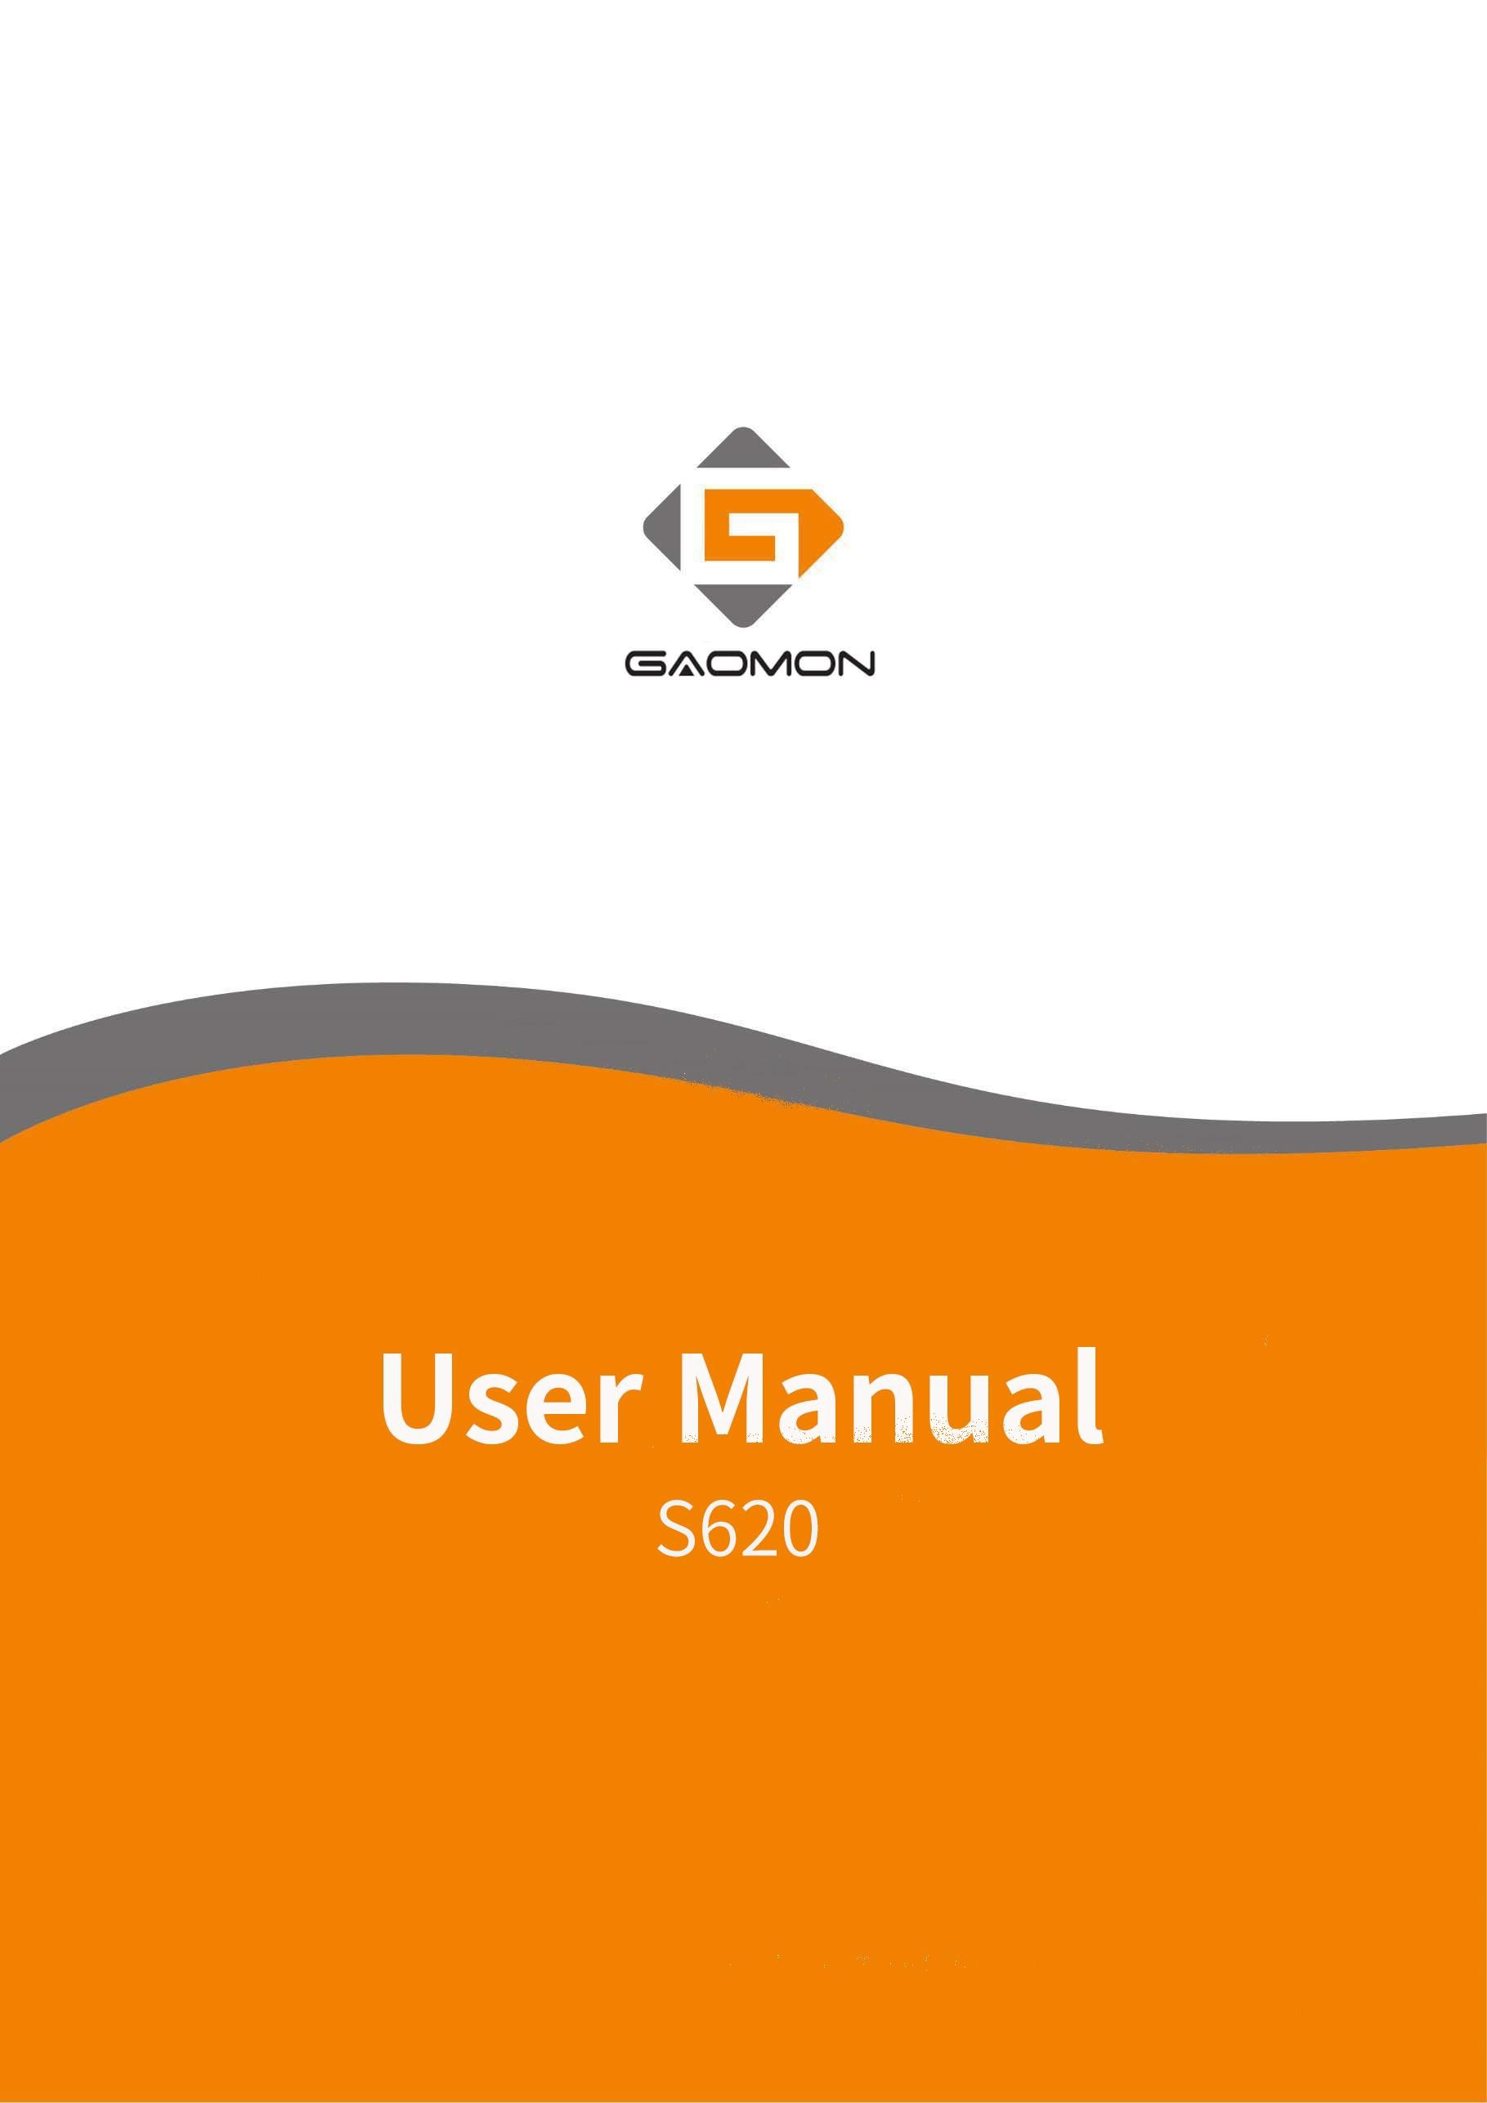

Precautions

- Please read this manual carefully before using, and keep it well for future reference.

- Before cleaning the tablet please unplug the power cord and wipe with a soft damp cloth, do not use any kind of detergents.
- Don’t expose this product to water or other liquids. Take care to never spill liquids onto the tablet and pen. Exposing this product to water or other liquids may cause product malfunction or electrical shock.
- Do not place the tablet on where is unstable or a height for children reaching easily in order to avoid danger. Prevent children from swallowing the pen nib or side switch. The pen nib, side switch, or other movable parts may accidentally be pulled out if children are biting on them.
- Power off your tablet in locations where/when electronic devices is not allowed. Because the tablet may cause other electronic devices to malfunction in some locations where/when the use of electronic devices is not allowed, such as within an airplane, be sure to turn off the tablet.
- Do not disassemble the tablet and pen. Do not disassemble or otherwise modify the tablet or pen. Such action may cause heat generation, ignition, electronic shock, or other damage, including human injury. Disassembling the product will void your warranty.
- While getting the components replaced, you are supposed to guarantee that the repairman is using the substitute components specified by the manufacturer. Unauthorized component replacement might cause fire, electric shocks or other dangers.
- Do not insert foreign material into the USB port or any other opening of this product. If a metal object or foreign material is inserted into a port or other opening of this product it may cause the product to malfunction or burn out, or cause electronic shock.

CONTENTS
Precautions 1
- Product Overview 3
  - Tablet Introduction 3
  - Product and Accessories 3
  - Connnecting to Computer 4
  - Connecting to Android Phone/Tablet 5
  - Driver Installation 6
    - OS Support 6
    - Install Driver 6
1.5 Pen Nib Replacement 6
- Function Setting 7
  - Device Connection Prompt 7
  - Working Area Setting 7
  - Shortcuts Keys Function Setting 9
  - Pen Buttons Function Setting 10
  - Pressure Sensitivity Setting 11
  - Pen Pressure Testing 11
  - Enable the Windows Ink feature 12
  - Mouse Mode(Only for specific models) 12
  - Data Export and Import 13
- Specifications 14
- Trouble Shooting 15
- Contact Us for After-sell Service 16

Product Overview

Tablet Introduction
Thanks for buying GAOMON S620 Tablet. This is a new generation of professional battery-free drawing tablet, which can greatly improve your work efficiency of painting and creation, and full of fun. You can freely painting and writing, depicting different lines and colors, just as the pen writes on the paper, which brings you a real shock experience.
To give you a better understanding and using of your tablet, please read this user manual carefully. The user manual only shows the information under Windows, unless otherwise specified, this information applies to both Windows and Macintosh systems.

Product and Accessories
    - Graphics Tablet

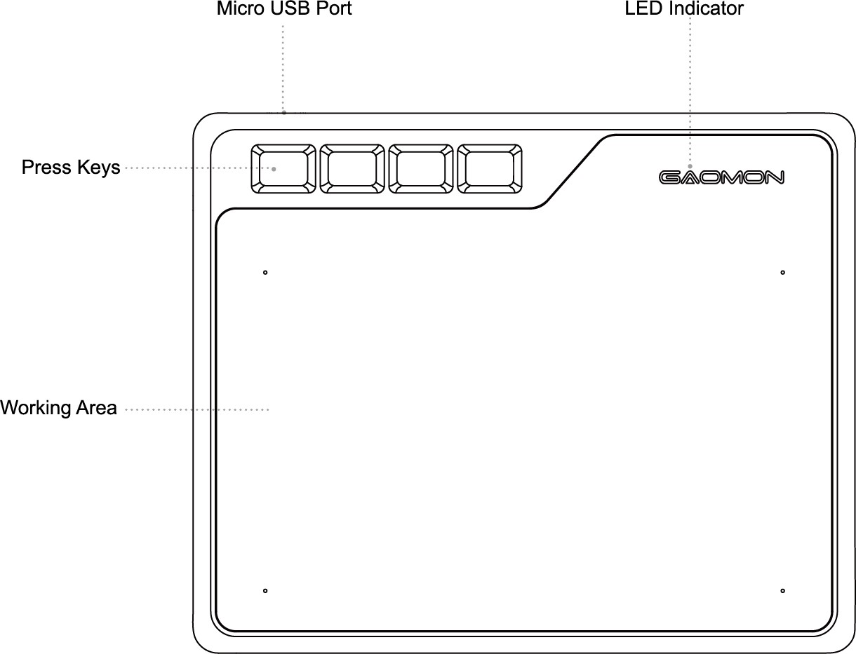

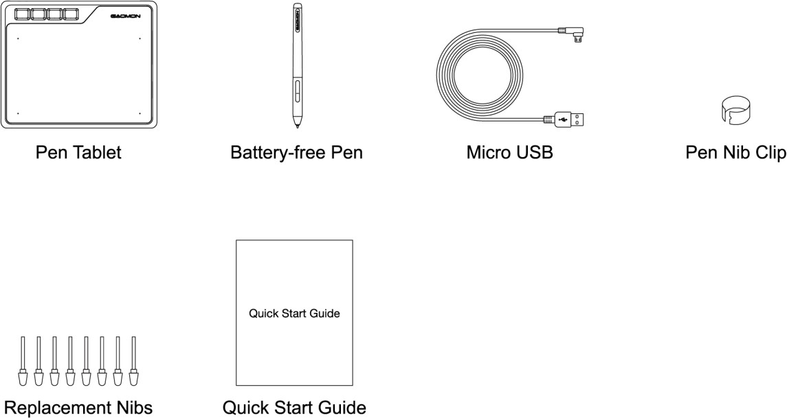
    - Packing List

Connnecting to Computer
Connect the tablet to your computer with USB cable.
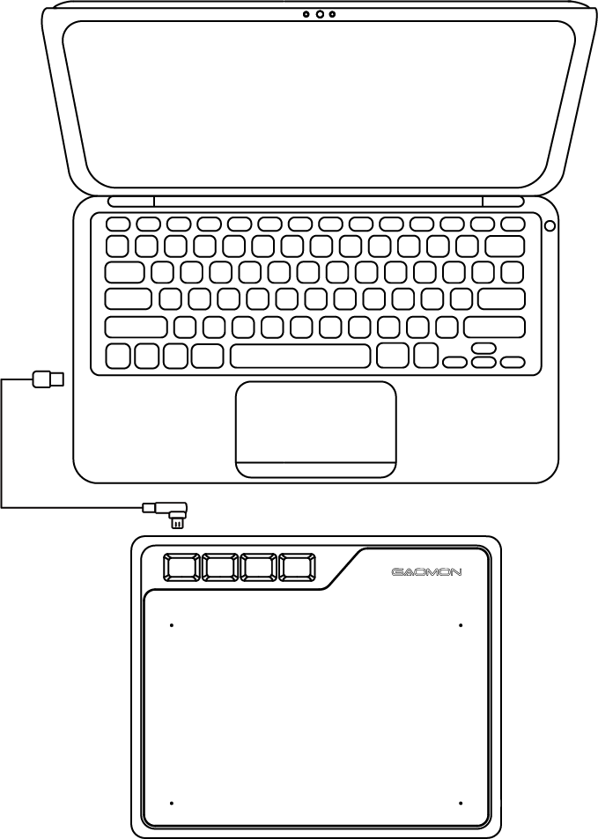

Connecting to Android Phone/Tablet
- Please use Android phone/tablet in portrait mode.
- Please make sure your phone/tablet OS is as following: Android OS 6.0 or later
- For some models, you need to go phone or tablet "Settings" then enable "OTG" function.
- Choose the right OTG Adapter from package, which depends on USB port type of your phone/tablet, then connect pen tablet to your phone following the illustra tions below:
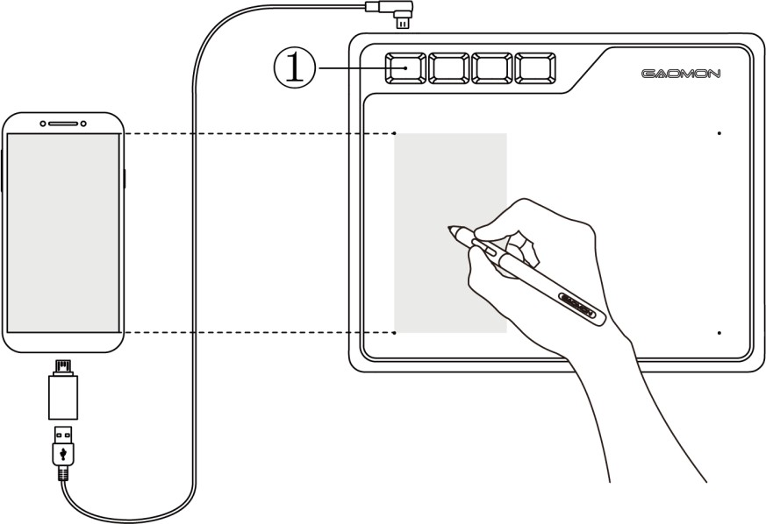

Notes:
- The pen tablet can works without installing any driver into your phone/tablet.
- Once connected, the tablet will automatically enter phone mode, in which the pen can only work in the left gray area.
- If not recognized the tablet to phone mode, please press the button ① for 3 seconds to enter phone mode
- Please note that the press keys of pen tablet and digital pen are not supported in phone mode.

Driver Installation
    - OS Support
Windows 7 or later，macOS 10.12 or later

    - Install Driver
Please download the driver from our website: www.gaomon.net/download
After finishing installation, you can find the driver icon in the system tray area, which means the driver was installed successfully; when you connect the tablet to computer, the icon will change to color , which means the driver has already recognized the tablet and you can start using it now.
Notice：
- Before installing, you need to uninstall other driver of similar products, including the old driver of this product.
- Before installing, please close all graphics software and anti-virus software to avoid unnecessary mistake.

1.5 Pen Nib Replacement
The nib will be wear off after using for a long time, then you need to replace a new nib.
- Use the pen nib clip to pull the old nib straight out of the pen. (①②）
- Insert a new pen nib into the stylus and push the nib until it stops. (③④）
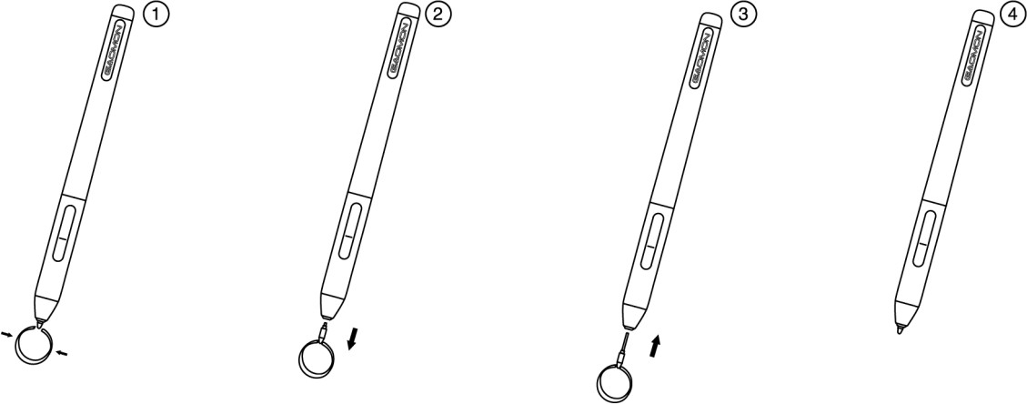

Function Setting

Device Connection Prompt
- Device disconnected: The computer does not recognize the tablet.
- Device connected: The computer has recognized the tablet.
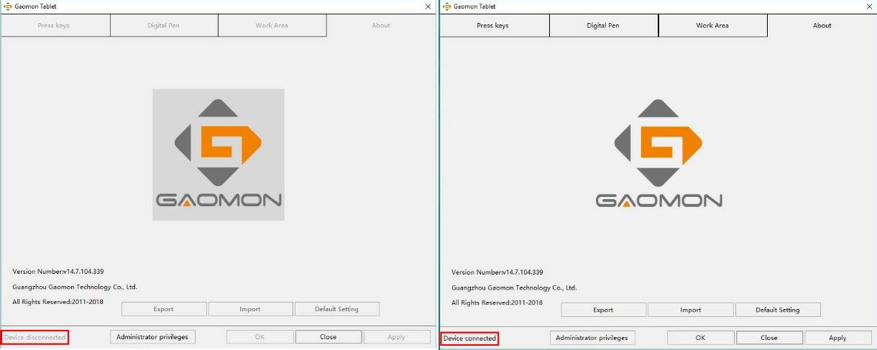

Working Area Setting
    - Using Multiple Monitors
Select the Working Area tab to define the relationship between pen movement on the tablet and cursor movement on the monitor screen.
By default the entire active area of tablet maps to the entire monitor. If more than one monitor is in use and you are in extended mode, you need to choose the related monitor on the driver interface which you are going to map to.
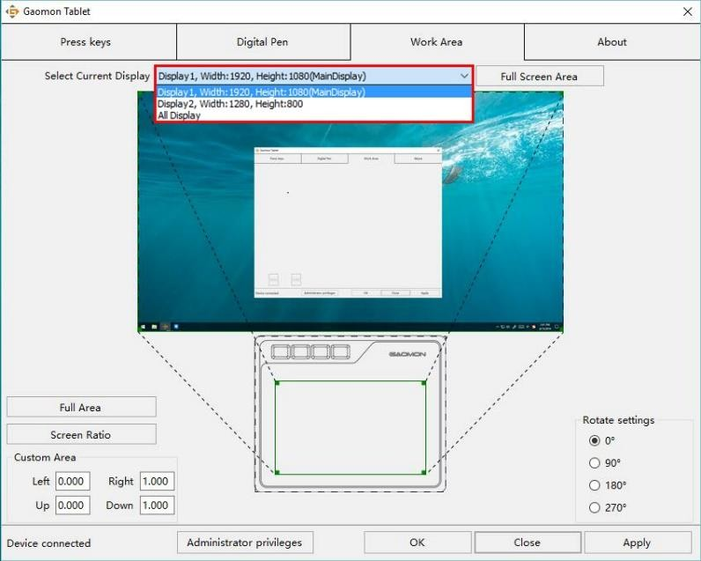If your monitors are in mirror mode (All monitors display the same content), the tablet maps to the entire space on each monitor and the screen cursor is displayed on each monitor simultaneously.
7 / 16 www.gaomon.net

    - Working Area Setting
Define the tablet area that will be mapped to the screen area.
- Full Area: the entire active area of the tablet. This is the default setting.
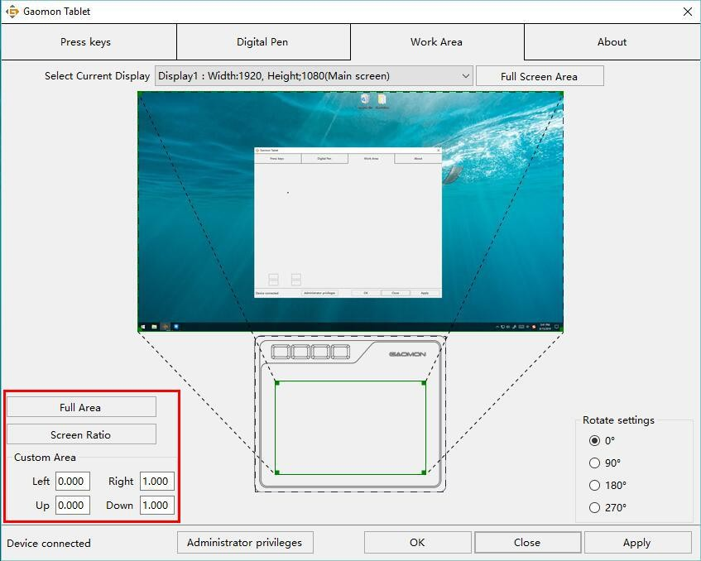
- Custom Area: 1.> Enter coordinate values. Or 2.> Drag the corners of the foreground graphic to select the screen area.
    - Rotate Working Area
By changing the direction of the tablet to adapt to the left and right hand operation. We provide four directions of choice.
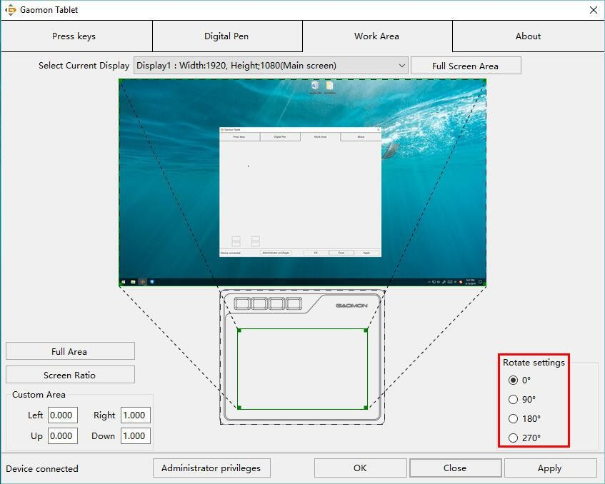

Shortcuts Keys Function Setting
Default Setting：Place the cursor on the shortcut key or click the press key to find the default values.
Customized Setting：Select the function to be achieved on the pop-up dialog box, then click APPLY or OK to take effect.
Enable/Disable Press Keys: Check/Uncheck”Enable Press Keys”
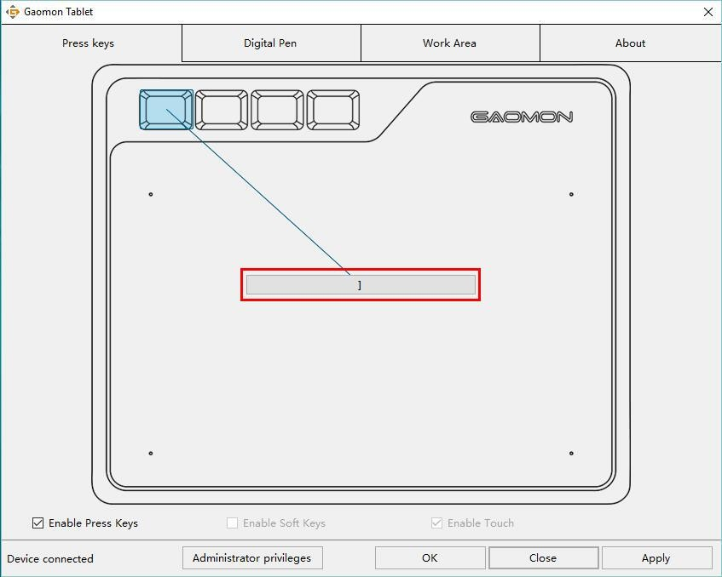
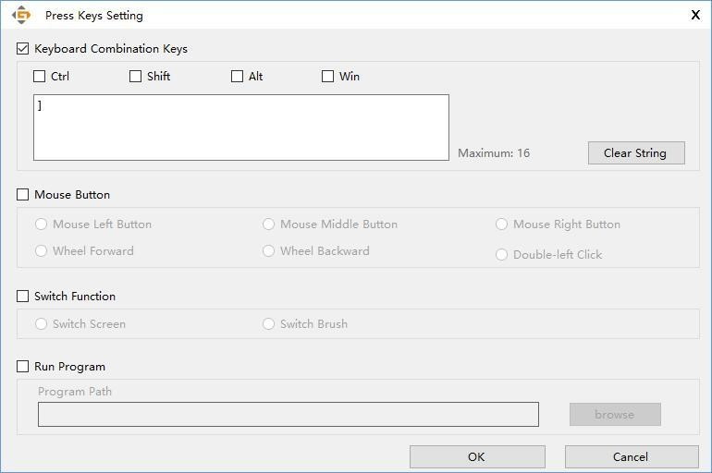

Pen Buttons Function Setting
Select the function to be achieved on the pop-up dialog box, then click APPLY or OK to take effect.
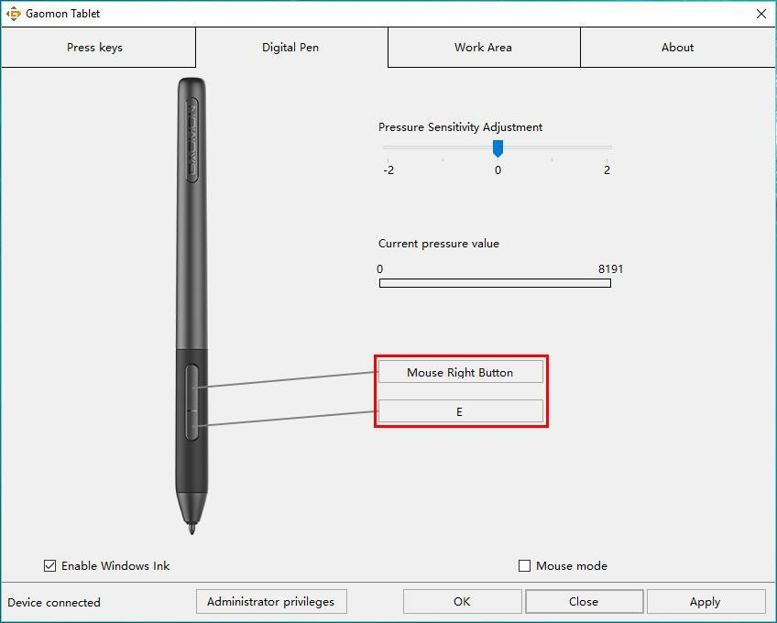
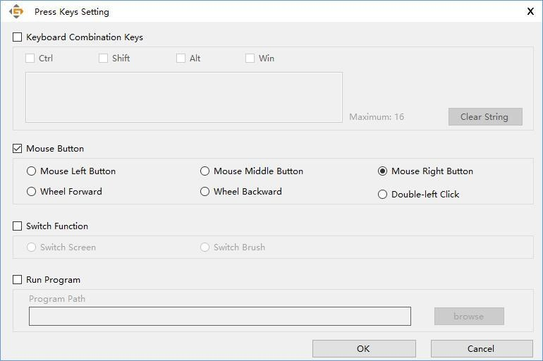

Pressure Sensitivity Setting
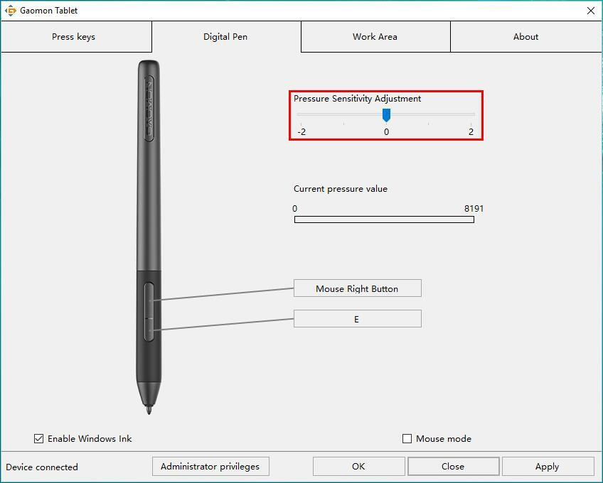
The pressure sensitivity will be changed by dragging the slider left or right, the smaller the value, the more the pressure sensitivity.

Pen Pressure Testing
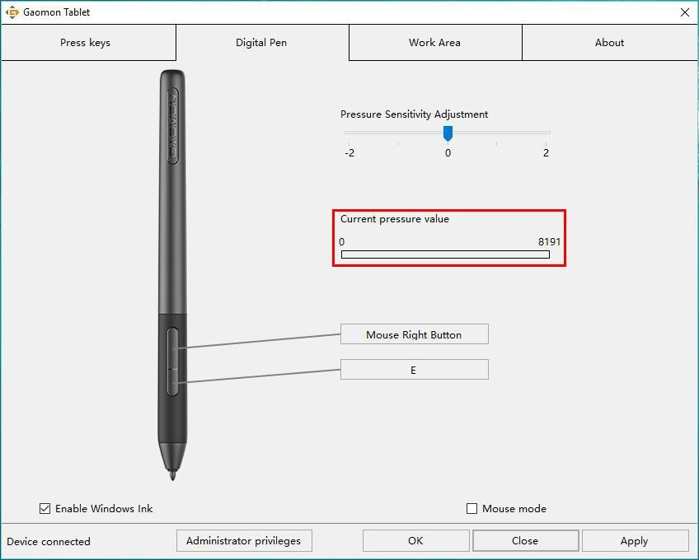
You can gradually apply pressure to the stylus on the screen to test the pressure level.

Enable the Windows Ink feature
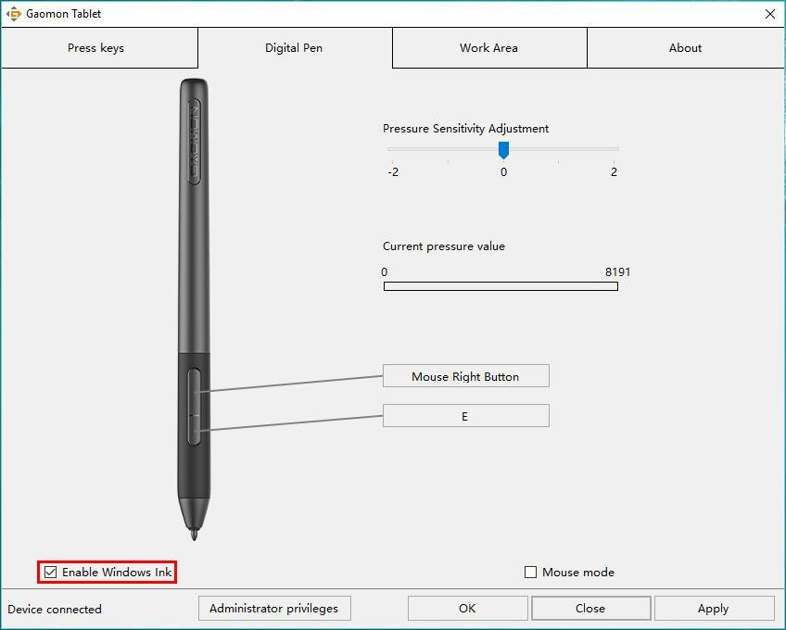
Microsoft Windows provides extensive support for pen input. Pen features are supported in such as Microsoft Office、Windows Journal、Adobe Photoshop CC、SketchBook 6 and so on.
  - Mouse Mode(Only for specific models)
As shown below, check the checkbox in front of the mouse mode to open the mouse mode. Under mouse mode, when you move the pen, the cursor moves following the relative coordinate principle, similar to moving the cursor with the mouse. This means you can click icons or select options at the edge of the screen without moving the pen to the edge of the working area.
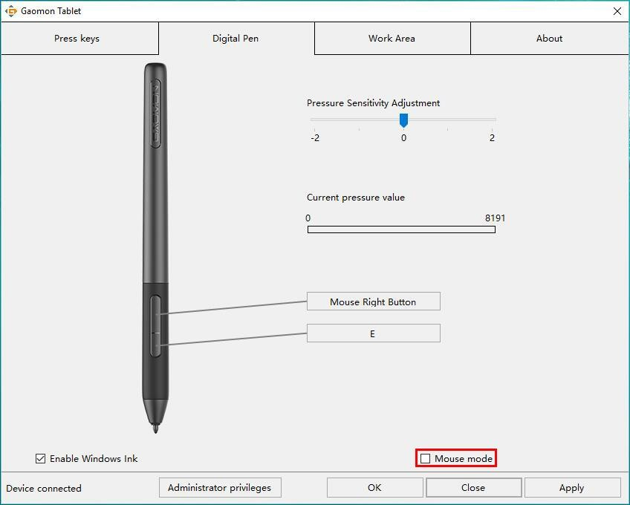

Data Export and Import
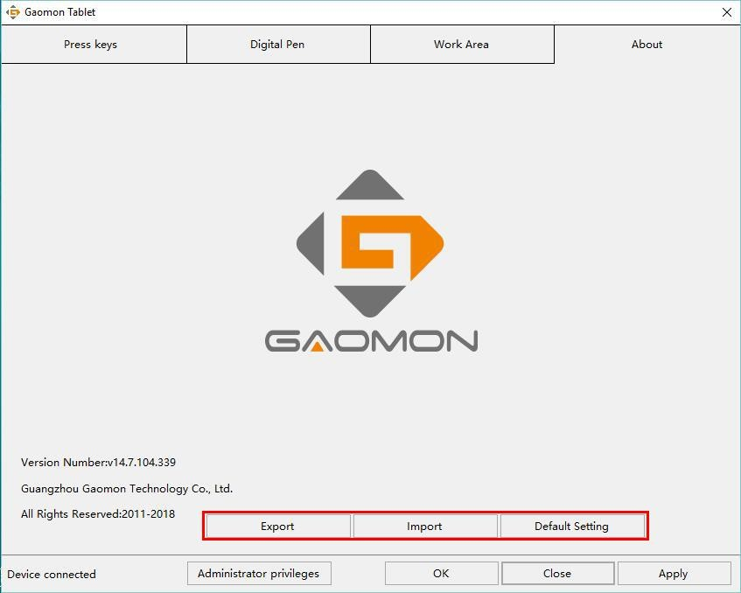
The driver supports exporting and importing your custom configuration data of the product, which is convenient for you to use different software and avoid the trouble of repeated settings.

Specifications

Model | S620
Touch Technology | Battery-free EMR
Working Area | 165.1x 101.6 mm（6.5*4in）
Dimension | 211 ×174×8mm
Touch Resolution | 5080LPI
Sensitivity Pressure | 8192 Levels
Report Rate | 266PPS
Accuracy | ±0.3mm
Pen Sensing Height | 10mm
Interface | Micro USB
Press Key | 4 Customized Press Keys
OS Support | Windows 7 or later, mac OS 10.12 or later
Model | AP32
Dimension | 160 x Φ12mm
Weight | 12g

Trouble Shooting

Abnormal Phenomena | Possible Solutions
There is no pressure in the graphics software but the cursor moves | You may have installed other tablet drivers or opened the drawing software when installing the driver. Please uninstall all drivers and close the drawing software, then reinstall  the driver. It’s better to restart your computer after finishing the installation.
The pen does not work | - Make sure you are using the pen that originally came with your tablet.  - Make sure you installed the driver correctly.
Press Keys does not work | - Make sure the Press Keys function were enabled in the driver.  - Make sure you have correctly defined the Press Keys.
The computer can’t enter sleep mode | When you are not using the tablet, please do not put the pen on the tablet surface, which will keep the computer awake.
The side button of the pen doesn’t work | When pressing the side button, please make sure that the nib didn’t touch the tablet surface and the distance between the nib and surface is more than 10mm.
The computer can’t recognize the tablet | Make sure the USB port is functional, if not, please change to another USB port.

For more FAQ, please feel free check：
https://blog.gaomon.net/faq-list/ or https://www.gaomon.net/question/

- Contact Us for After-sell Service

GAOMON TECHNOLOGY CORPORATION
www.facebook.com/Gaomonpentablet twitter.com/Gaomonpentablet
service@gaomon.net
https://www.gaomon.net

