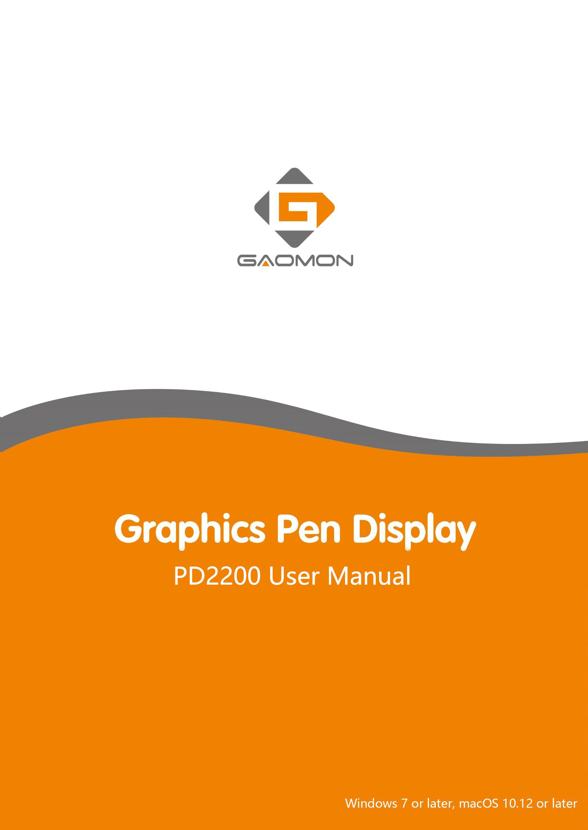

Precautions
- Please read this manual carefully before using, and keep it well for future reference.
- Before cleaning the display please unplug the USB cable and wipe with a soft damp cloth, do not use any kind of detergents.
- Please don’t place the display near water sources such as bathtub, washbasin, sinks, washing machine, damp basement, swimming pool, etc.
- Do not place the display on where is unstable or a height for children reaching easily in order to avoid danger.
- Do not place the display and digital pen close to the magnetic field.
- The grooves and holes on the back case is designed for ventilation to prevent the monitor from overheating. Please don’t place the display on beds, sofas, carpets or in embedded device.
- Only power supplies shown on the nameplate can be used for the display. If you have questions about the power supply which you are using, please consult the distributor of your display.
- To protect your display, please switch off the power when it is not in use. During blackouts or not using for long time, please unplug the display from the socket.
- Don’t overload the socket or lengthen the power wire, which may lead to electric shocks.
- Make sure no foreign bodies get inside the monitor through grooves and prevent liquid from splashing on the display as to prevent short-circuit or fire.
- If the display has a breakdown, do not open the main case and try to repair it by yourself. Please ask for a service for proper repair and maintenance.
- When the following situations occur, please unplug the power adapter and you may need a service for full repair and maintenance:
- The power wire or plug is damaged or worn out;
- There is liquid splashed inside of the display;
- The display has fallen or the LCD is broken;
- When obvious abnormalities occur to the display.
- While getting the components replaced, you are supposed to guarantee that the repairman is using the substitute components specified by the manufacturer. Unauthorized component replacement might cause fire, electric shocks or other dangers.

Contents
- Product Overview 3
  - Product Introduction 3
  - Product and Accessories 3
  - Display Connection 5
  - Driver Installation 5
  - Pen Nib Replacement 6
- OSD Setting 7
- GAOMON Driver Setting 8
  - Device Connection Prompt 8
  - Working Area Setting 8
  - Press Keys Function Setting 10
  - Pen Button Setting 11
  - Pressure Sensitivity Setting 12
  - Pen Pressure Testing 12
  - Enable the Windows Ink feature 13
  - Calibration 13
  - Data Export and Import 14
- Specifications 15
- Trouble Shooting 16
  - Possible Breakdowns Related to DISPLAY 16
  - Possible Breakdowns Related to FUNCTIONS 17

Product Overview

Product Introduction
Thanks for choosing GAOMON® PD2200 Pen Display. This is a new generation of 21.5'' large size professional drawing display, which can greatly improve your work efficiency of painting and creation, and full of fun. You can freely painting and writing, depicting different lines and colors, just as the pen writes on the paper, which brings you a real shock experience.
To give you a better understanding and using of your display, please read this user manual carefully. The user manual only shows the information under Windows, unless otherwise specified, this information applies to both Windows and Macintosh systems.

Product and Accessories
    - Display Overview

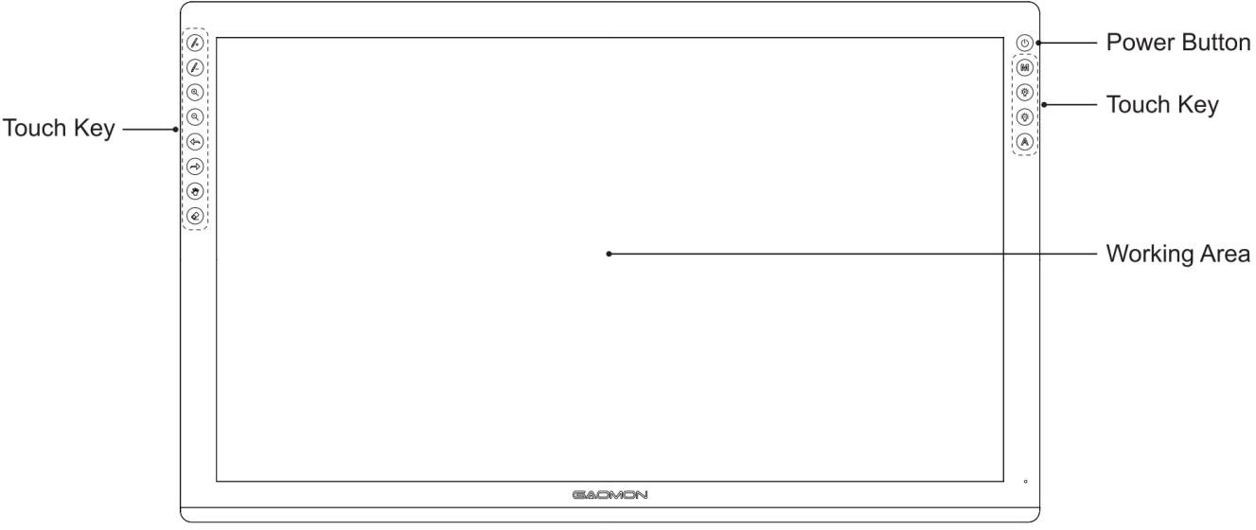

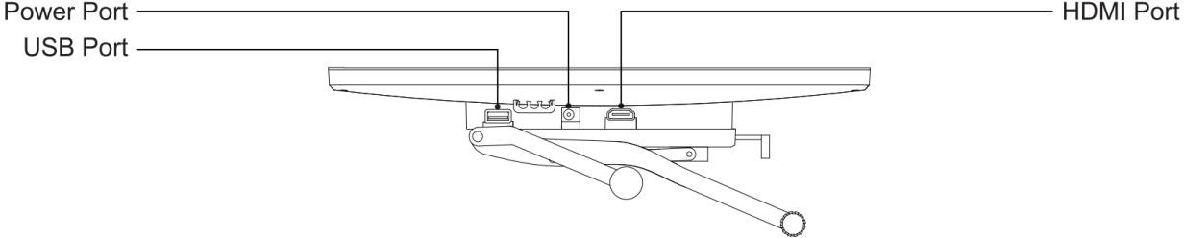

    - Stylus Pen

The stylus pen is a battery-free pen with 8192 levels pressure sensitivity and two customizable button.
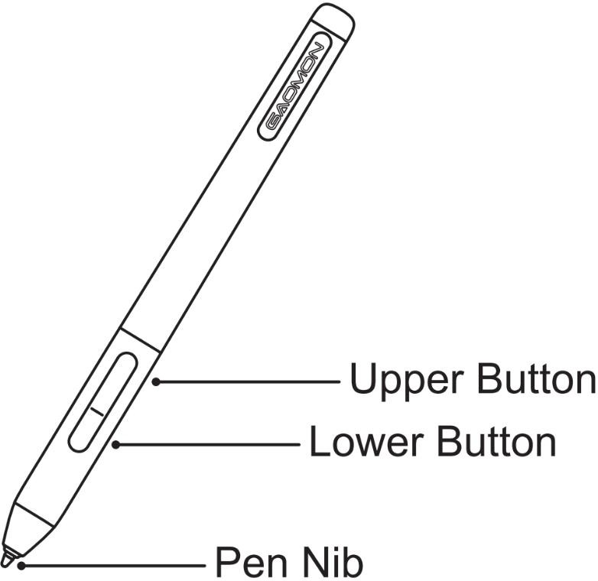

    - Adjustable Stand

We designed this ergonomic adjustable stand specially for your pen display, you can adjust the angle of the display according to your usage habit, and make you feel more comfortable when painting and creating.
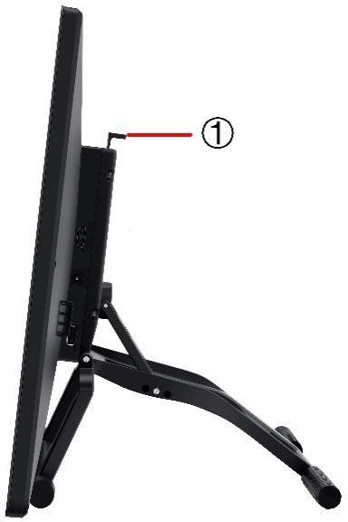
By dragging this switch to adjust the stand angle from 15°-85°

    - Other Accessories
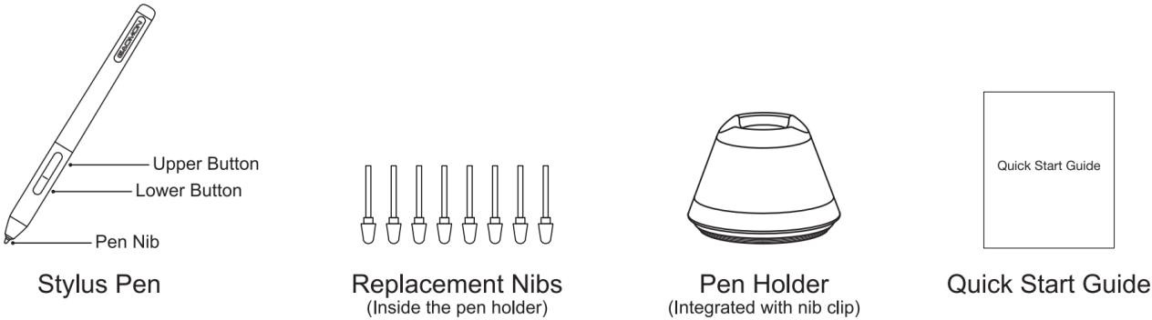
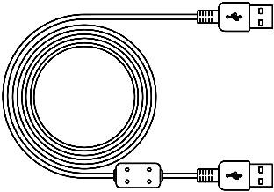
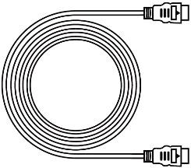
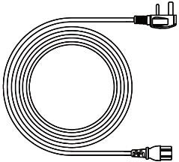
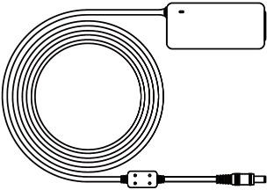

USB Cable HDMI Cable Power Cable Power Adapter

Display Connection
- As shown on the below, connect the pen display to your computer with attached power adapter, HDMI cable and USB Cable.
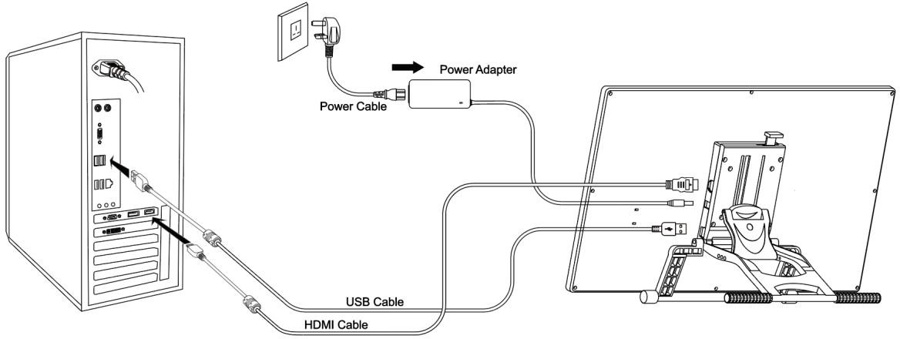
- Press the power button on the top of the display to power on the display

Driver Installation
    - OS Support
Windows 7 or later，macOS 10.12 or later

    - Install via Download
Please download the driver from our website: www.gaomon.net/download/
After finishing installation, you can find the driver icon in the system tray area, which means the driver was installed successfully; When you connect the display to computer, the icon will change to color , which means the driver has already recognized the display and you can start using it now.
Notice：
- Before installing, you need to uninstall other driver of similar products.
- Before installing, please close all graphics software and anti-virus program to avoid unnecessary mistake;

Pen Nib Replacement
- The nib will be worn out after using for long time, then you need to replace a new nib.
- Anticlockwise rotate the holder to open the cover, then take a new nib out.
- Insert the pen nib into the bottom hole and tilt the pen to pull out the nib.
- Insert the new nib into the pen and push it straight until it stops.
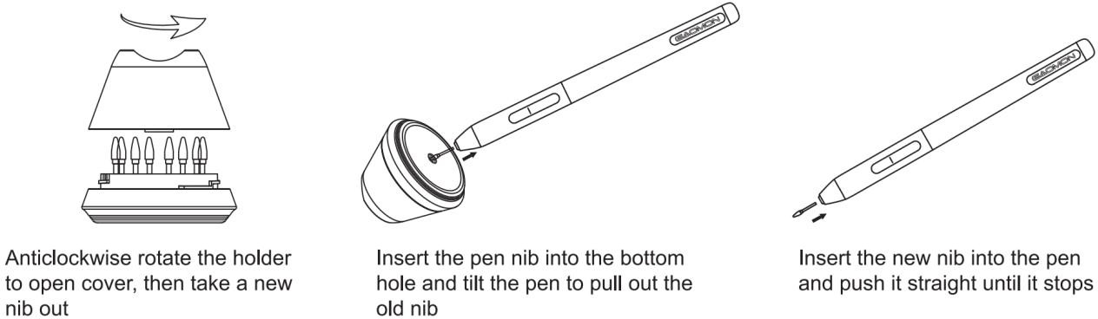

OSD Setting

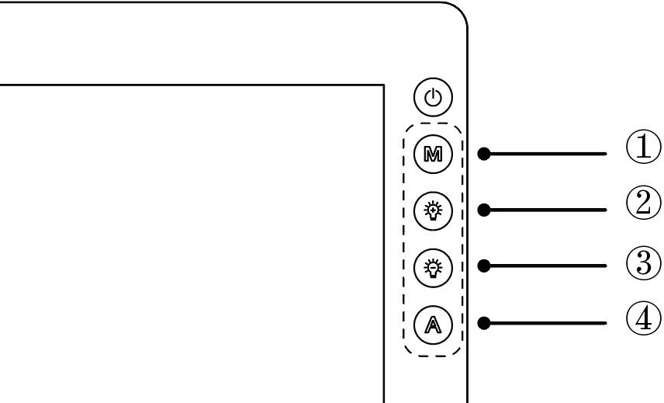

Turn off/on the display: Long press the power key for 3 seconds.
Unlock OSD keys: Long press any of ①②③④ for 6 seconds
OSD keys automatically get locked: the OSD panel will be hidden without movement for more than 15 seconds after exiting the menu.
Manually exit the MENU: Touch Auto key for 0.5 seconds
Automatically exit the MENU: without movement for 10 seconds
Enter OSD Menu:
1 MENU: Call up the menu or confirm.
2 +: Up/ Right/ Increase.
3 -: Down/ Left/ Decrease
Auto: Back to previous menu/Exit.
4

GAOMON Driver Setting

Device Connection Prompt
- Device disconnected: The display has not been recognized by your computer successfully yet.
- Device connected: has been recognized by your computer successfully already.
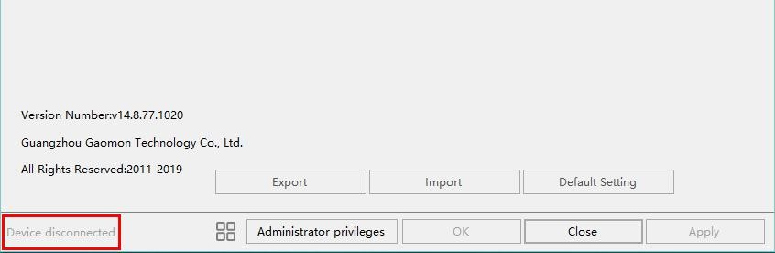
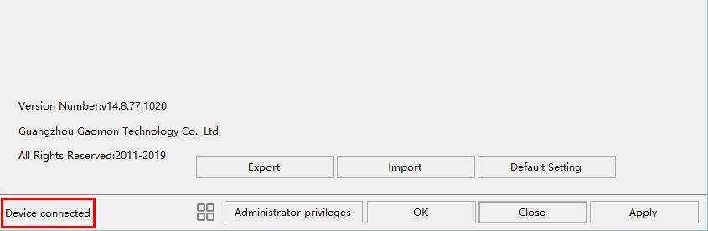

Working Area Setting
    - Using Multiple Monitors
When the GAOMON Display and other monitors are used in the same system, the movement of the screen cursor on the standard display depends on the system configuration.
If the secondary display is a mirrored mode connection, this display and another monitor will display exactly the same image and screen cursor movement.
If you are in the extended display mode, you need to set the display on the driver that which portion of the display screen your display will map to.

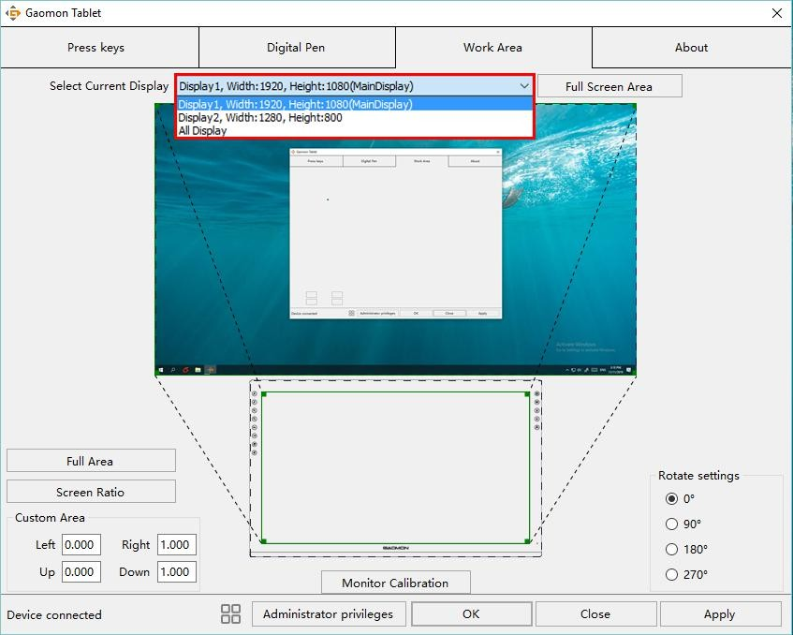

    - Working Area Setting
Define the display area that will be mapped to the screen area.
- Full Area: the entire active area of the Display. This is the default setting.
- Same Ratio with LCD.
- Customized Area: 1.> Enter coordinate values. Or 2>. Drag the corners of the foreground graphic to select the screen area.
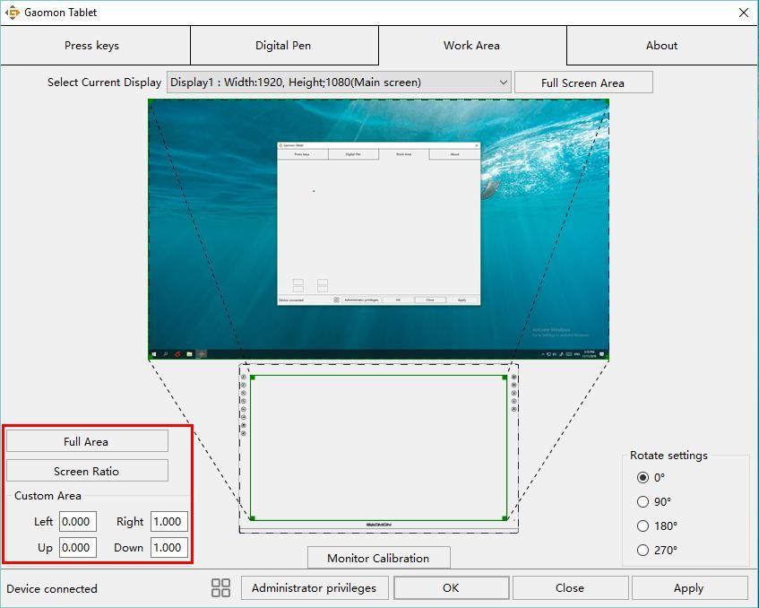

    - Rotate Working Area
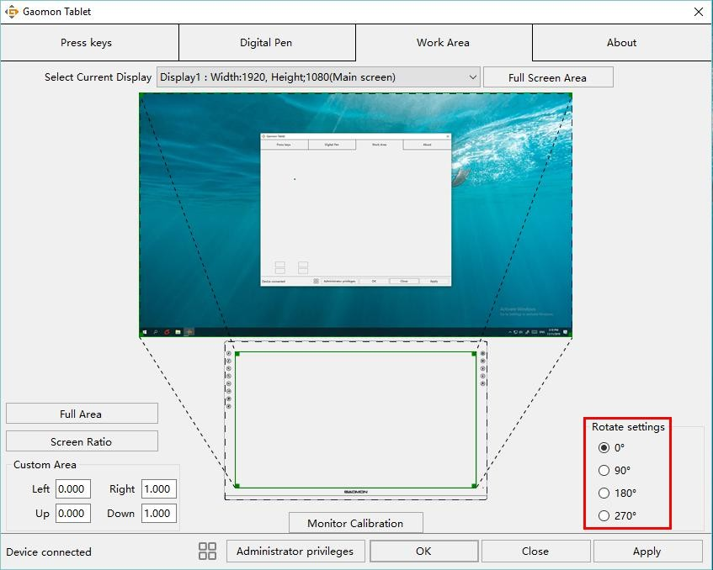
By changing the direction of the display to adapt to the left and right hand operation. We provide four directions of choice.

Press Keys Function Setting
Default Setting: Place the cursor on the button or click the button icon to see the default values for the press keys
Customizable Press Keys: Select the function to be achieved on the pop-up dialog box, then click APPLY or OK to take effect.
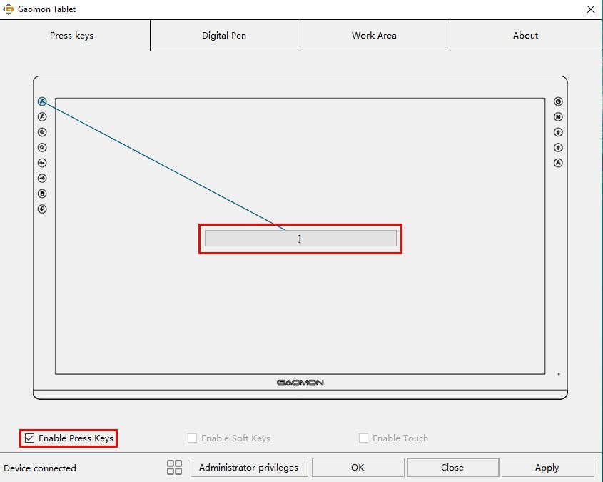
Enable/Disable Press Key: Check/Uncheck ”Enable Press key ”

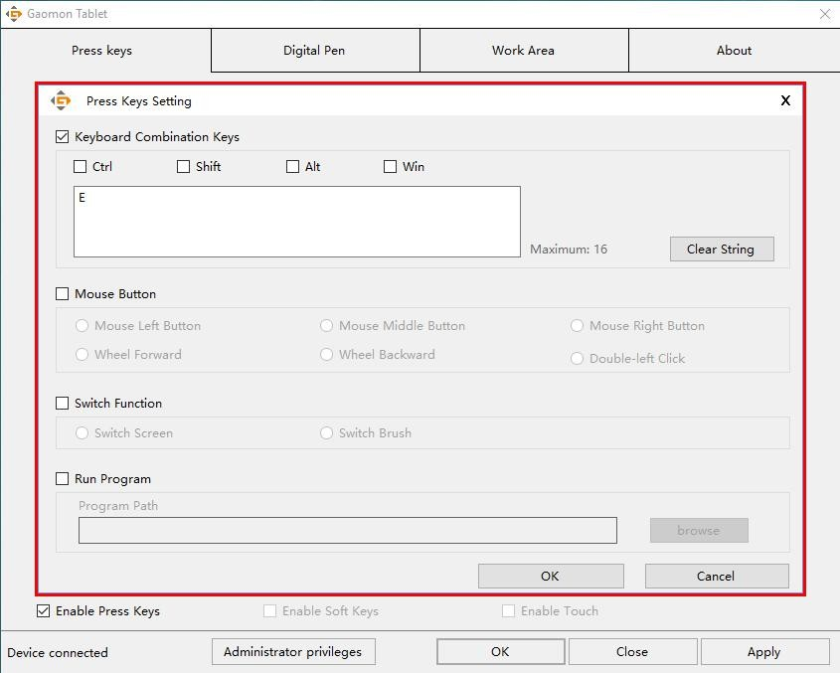

Pen Button Setting
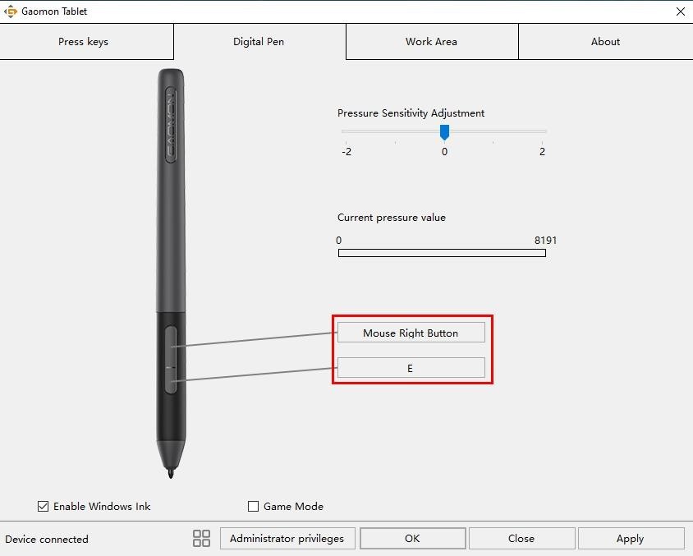
Select the function to be achieved on the pop-up dialog box, then click APPLY or OK to take effect.

Pressure Sensitivity Setting
The pressure sensitivity will be changed by dragging the slider up and down, the
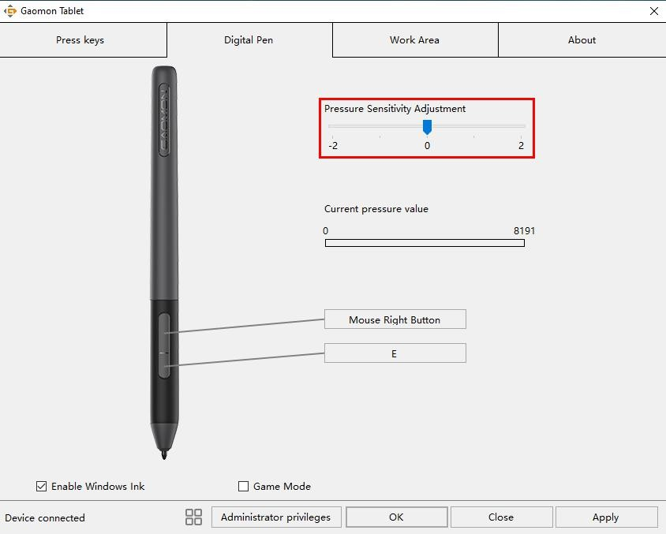
smaller the value, the more sensitive the pressure.

Pen Pressure Testing
You can gradually apply pressure to the stylus on the screen to test the pressure level.
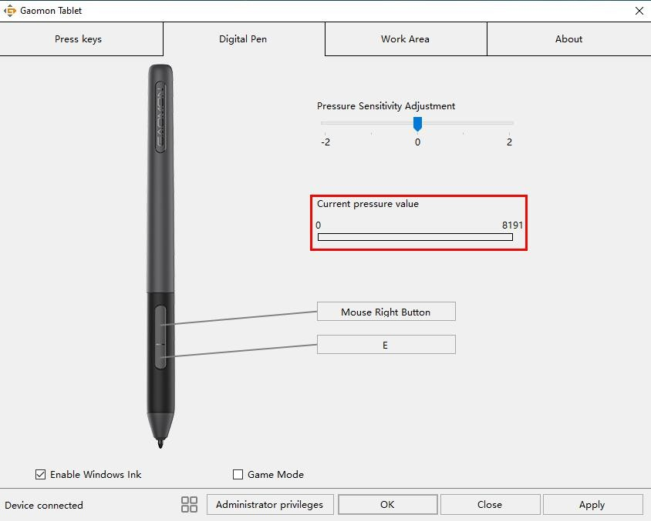

Enable the Windows Ink feature
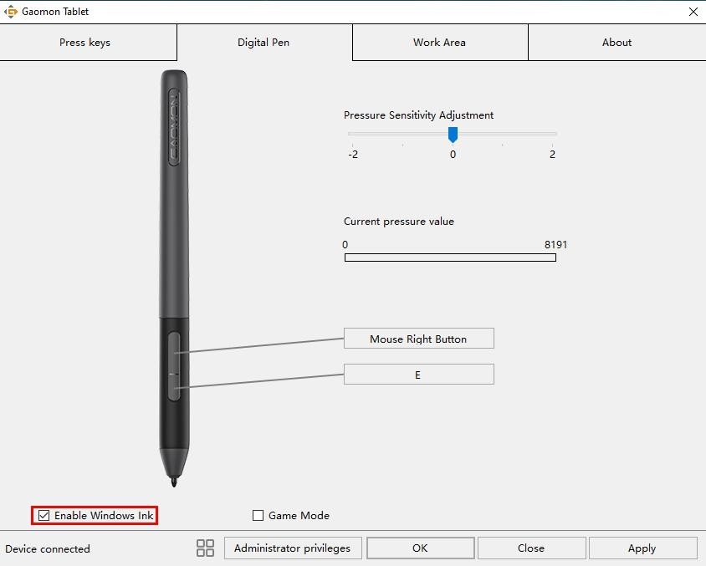
Microsoft Windows provides extensive support for pen input. Pen features are supported in such as Microsoft Office、Windows Journal、Adobe Photoshop CC、SketchBook 6 and so on.

Calibration
Monitor Calibration: Click the red point of the cross center appearing on the screen to complete the calibration.
Restore Factory Settings: Click "Restore Default" to restore to the factory settings. Cancel Calibration: Click"Cancel calibration ” or press ESC on the keyboard to cancel the calibration.
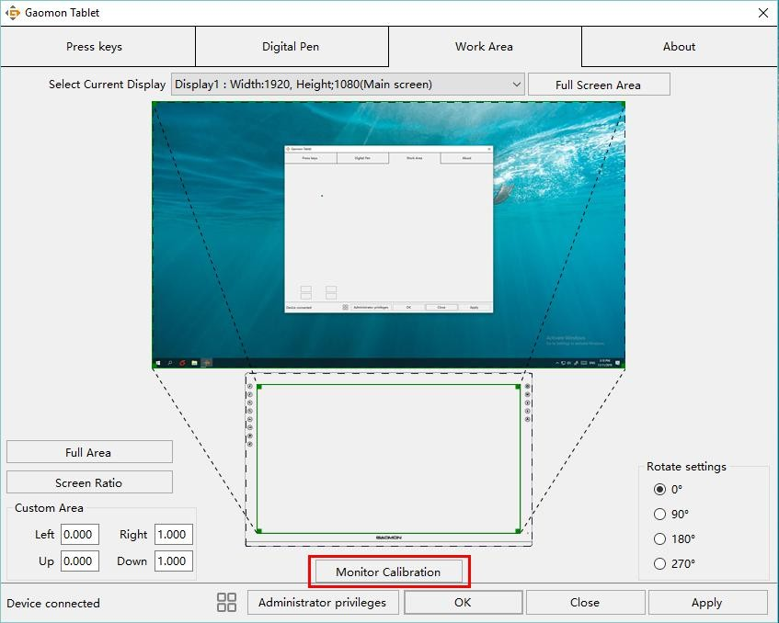

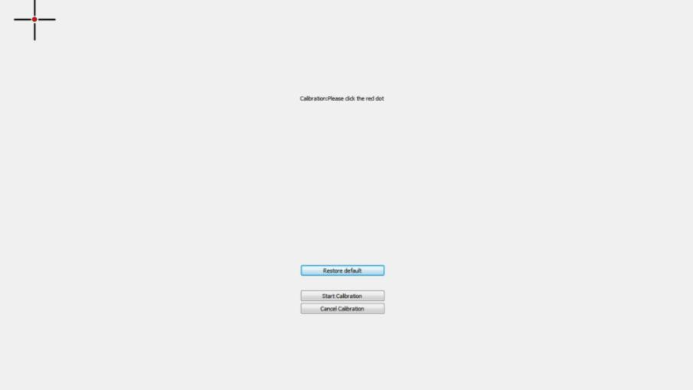

Data Export and Import

The driver supports exporting and importing your customized configuration data of the product, which is convenient for you to use different software and avoid the trouble of repeated settings.
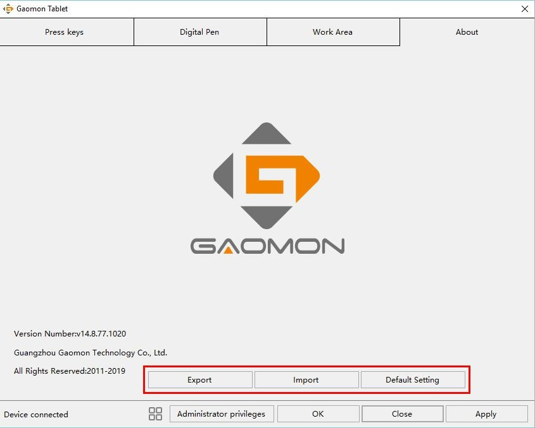

Specifications

Model |  | PD2200
Screen | Panel Size | 21.5inch
 | Resolution | 1920 x 1080(16:9)
 | LCD Type | LCD IPS
 | Active Area | 476.64 x 268.11mm
 | Contrast Ratio | 2000:1
 | Brightness | 220cd/m2
 | Response Time | 25ms
 | View Angle | 89°/89°(H)/89°/89°(V)  (Typ.)(CR＞10)
 | Gamut | 92%(NTSC)
Touch | Touch Type | Battery-free Electromagnetic Resonance
 | Resolution | 5080LPI
 | Pressure Level | 8192
 | Accuracy | ±0.5mm（Center）  ±3mm（Corner）
 | Sensing Height | 10mm
 | Report Rate | 266PPS
General | Input Voltage | 100-240VAC, 50/60Hz
 | Output Voltage | DC12V 3A
 | Video Interface | HDMI/DC
 | Press Key | 8 Customized Press Key
 | Dimension | 452.4 x 252 x 19.5mm
 | Adjustable Stand | 15°-85°
 | OS Support | Windows 7 or later,  macOS 10.12 or later
Digital Pen | Model | Artpaint AP32
 | Net Weight | 12g
 | Dimension | 160 x Φ12mm
 | Buttons | Two Customizable Press Key

Trouble Shooting
  - Possible Breakdowns Related to DISPLAY

Abnormal Phenomena | Possible Solutions
Power indicator does not flash | *Make sure power is on | *Check the socket and power cable
No signal--saving power--all black | - Make sure the HDMI cables are well connected.  - If you use a desktop, make sure the HDMI cable is plugged into the graphic card on the tower, but not into the motherboard.  - If you use a Windows OS computer, make sure to press ''Windows+p'' on keyboard, then choose Duplicate or Extend. Don’t choose Computer Only or Projector Only.  - If there is no HDMI port on your computer, you need an extra HDMI adapter. We DON’T recommend a USB to HDMI adapter. Also we don’t recommend a USB hub. We recommend DVI/ VGA/ Display Port/ Type-C/ Thunderbolt, etc to HDMI adapters.
Nothing displays at all，with no indicator light. | 1.Make sure the power cord is well connected. 2.Try different power socket.
Displays wallpaper & taskbar of computer monitor only. | - It is because you are under extended mode right now. It is normal situation.  - If you are not familiar with extended mode, we recommend you to use in Duplicate/Mirror mode. Windows OS: Press keyboard combination---windows+p---then choose Duplicate  Mac OS: System Preference---Displays--- Arrangement--- Check "Mirror Displays"  - If you decide to use in Extended mode. Make sure to choose PD2200 as Work Area in GAOMON Driver. It is usually ''Display 2''.
Images are blurred | Please set the display resolution with 1920 x 1080.
Lack of colors | Check the pins of the signal wire are not bent or fractured.
There is chromatic aberration | As the regional color temperature is different, so minor chromatic aberration is a normal phenomenon.
Images jitter or ripple images | It is likely that there is electric equipment nearby that brings
16 / 17 |  | www.gaomon.net

about electronic interference.

  - Possible Breakdowns Related to FUNCTIONS
appear

Abnormal Phenomena | Possible Solutions
Pen doesn’t work and no pressure in the graphics software | - When pen does not work in art programs only: Uninstall the driver and reinstall it. If you use Windows OS, make sure to ''run as administrator'' when installing the driver. (But not ''run as administrator'' on desktop after the driver has been well installed already)  - When pen does not work everywhere: Try re-inserting the USB cable. Try different USB ports on computer. Try different computer.
Cursor movement is abnormal | Try re-inserting the USB cable or restarting your computer.
The side button of the pen doesn’t work | When pressing the side button, please make sure that the nib didn’t touch the glass surface and the distance between the nib and surface is within 10 mm
There is a deviation between  the tip and the cursor | Try calibration

GAOMON driver indicates ''device connected'', but the pen doesn ’ t respond in Mac OS
10.14 or above versions.
Find answer here:

https://www.gaomon.net/question/macos_mojave_catalina_solution.html
Note:
For more information, please contact us with our email: service@gaomon.net or find answer here https://blog.gaomon.net/faq-list/

17 / 17 www.gaomon.net

