User Manual

M106K
Professional Graphics Tablet

Thank you for choosing and purchasing M106K, which is a professional graphics tablet.

To give you a better understanding and using of this product, please read this user manual carefully before using.

Compatibility: Microsoft Windows 7/8/10, Mac OS X 10.10 or later.

This product is compliant with the standards prescribed by the state.

This user manual only display the windows information, it will also apply to MAC OS unless otherwise specified.

© Gaomon Technology Corporation All Rights Reserved.

Contents
- Introduction and Installing 4
  - Packing List 4
  - Product Overview 4
    - Front View 4
    - Rear View 4
    - Stylus Pen(ArtPaint AP20) 5
      - Replace the pen nib 5
      - Charging the pen 5
  - Tablet and Driver Installing 6
    - OS Compatibility 6
    - Driver Installing 6
    - Install the tablet 6
- Setup and Operation Guide 6
  - Working Area Setting 6
    - Using Multiple Monitors 6
    - Working Area Setting 7
    - Rotate Working Area 7
  - Press Keys Function Setting 8
  - Pen Button Setting 8
  - Pressure Sensitivity Setting 9
  - Pen Pressure Testing 9
  - Enable the Windows Ink feature 10
  - Data Export and Import 10
- Troubleshooting 11
- Product Specification 11

Introduction and Installing

Packing List

Make sure that all of the following contents are included after unpacking:

Graphics Tablet x 1

Stylus Pen（ArtPaint AP20） x 1

Pen Nibs x 4

Pen Nib Clip x 1

Mini USB Cable x 1

Pen Charging Cable x 1

Quick Start Guide x 1

Please contact the agency where you purchased the product if there is a defect or missing part.

Product Overview

Front View

Rear View

Stylus Pen(ArtPaint AP20)

A：Charging Port

B：Upper Button: Mouse Right Key function(By default) C：Lower Button: Switch Brush(By default)

D：Pen Nib: Mouse Left Key function

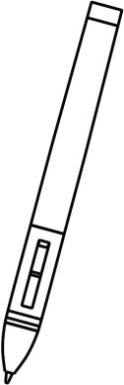C
A
B
D

Replace the pen nib

When the nib gets too short or develops a sharp edge, you can replace it with one of the spare nibs that comes with the pen.

Use the pen nib clip to pull the old nib straight out of the pen.

Insert a new pen nib into the stylus pen and push the nib until it stops.
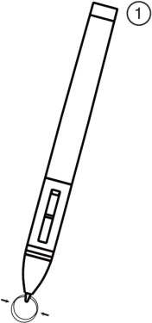
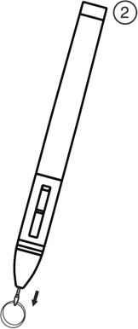
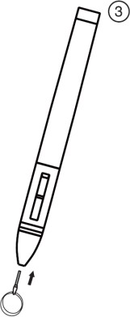
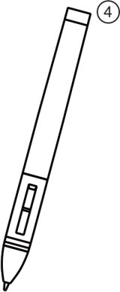

Charging the pen

Please charge the pen with the rechargeable cable when power of the pen runs out. It can be connected to computer, power supply or power bank to charge.

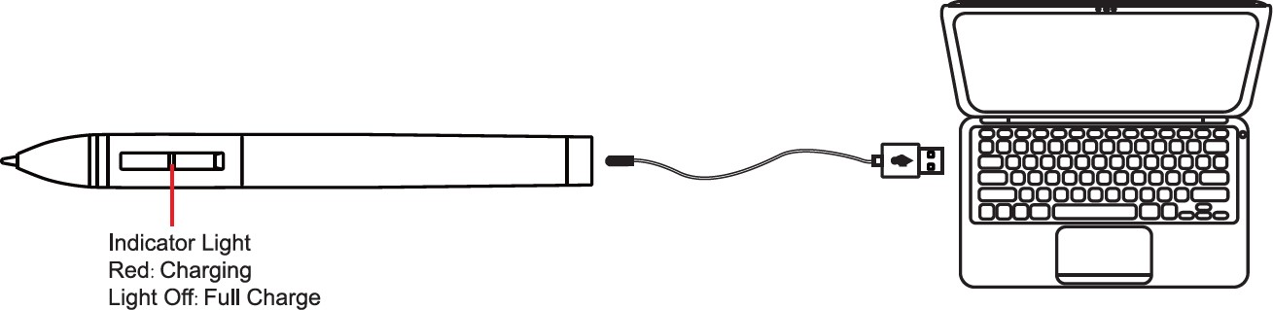

Tablet and Driver Installing

OS Compatibility

Before installing the Tablet, make sure your PC Operation System (OS) is Windows 7 / 8 / 10 and MAC 10.10 or later

Driver Installing

please download the driver from our website: www.gaomon.net.

Please close all graphics software and anti-virus program before installing the driver. 3）Please uninstall other tablet driver if you have installed them.

4）Then double click the driver program and follow the instruction to finish the installation.

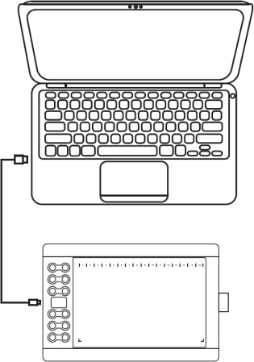
Install the tablet
- Connect the tablet to your computer with the mini USB cable.
- Now you can use the pen to operate
the tablet.

Setup and Operation Guide

Working Area Setting

Using Multiple Monitors
Select the Work Area tab to define the relationship between pen movement on the tablet and cursor movement on the monitor screen.
By default the entire active area of tablet maps to the entire monitor.If more than one monitor is in use and you are in extended mode, you need to choose the related monitor on the driver interface which you are going to map to.
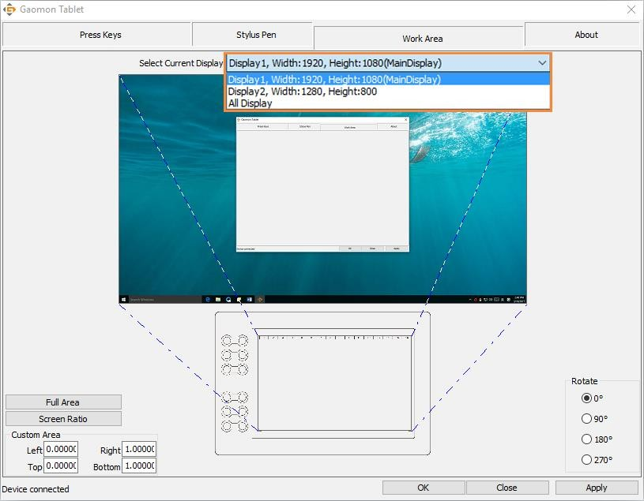
If your monitors are in mirror mode (All monitors display the same content), the tablet maps to the entire space on each monitor and the screen cursor is displayed on each monitor simultaneously.

Working Area Setting
Define the tablet area that will be mapped to the screen area.
- Full Area: the entire active area of the tablet. This is the default setting.
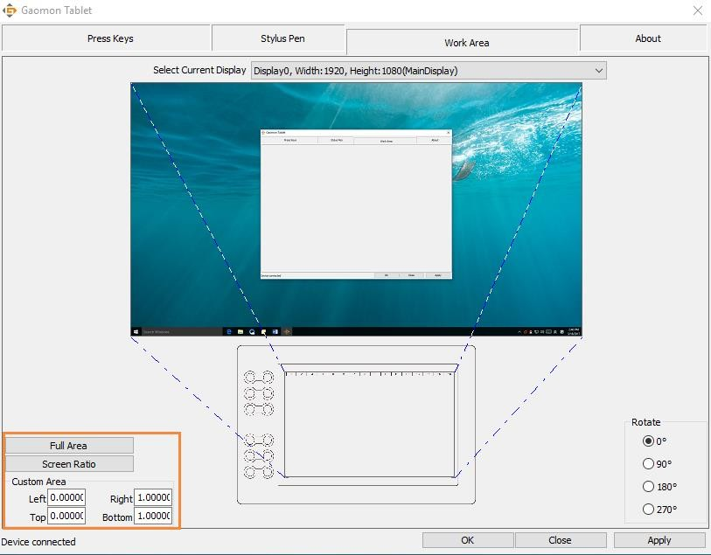
- Customized Area: <1> .Enter coordinate values. Or<2>. Drag the corners of the foreground graphic to select the screen area.

Rotate Working Area
By changing the direction of the tablet to adapt to the left and right hand operation. We provide four kinds of choice.
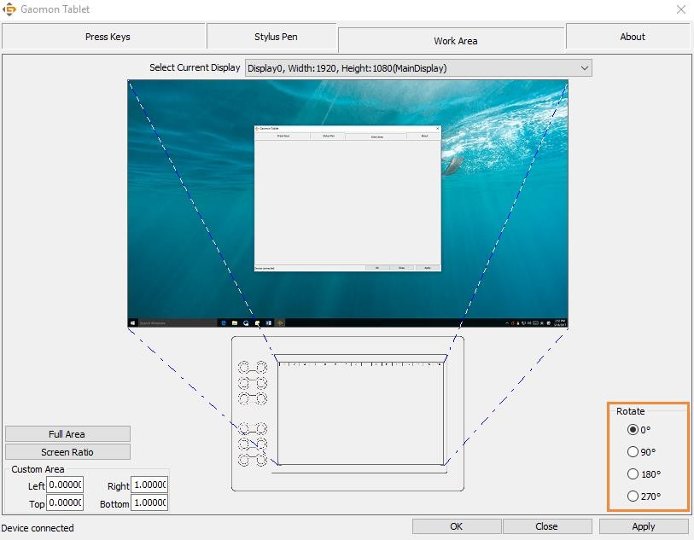

Press Keys Function Setting
Default Setting：Place the cursor on the button or click the button icon to see the default values for the press keys Customized：Select the function to be achieved on the pop-up dialog box, then click APPLY or OK to take effect.
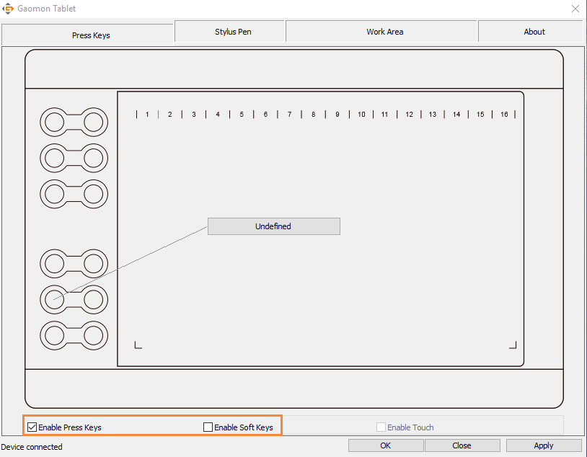
Enable/Disable Press Keys: Check/Uncheck“Enable Press Keys” Enable/Disable Soft Keys: Check/Uncheck“Enable Soft Keys”

Pen Button Setting

Select the function to be achieved on the pop-up dialog box, then click APPLY or OK to take effect.

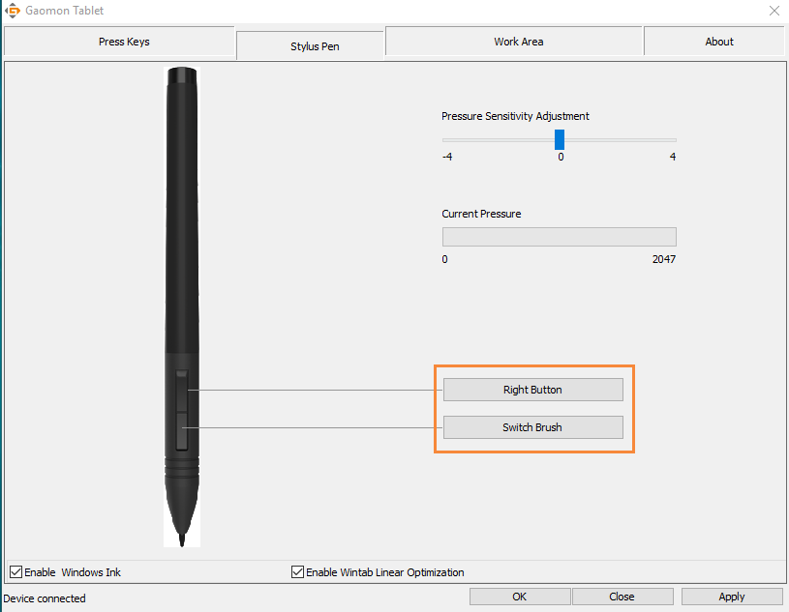
8 / 11 www.gaomon.net

Pressure Sensitivity Setting
The pressure sensitivity will be changed by dragging the slider up and down, the smaller the value, the more pressure sensitive.
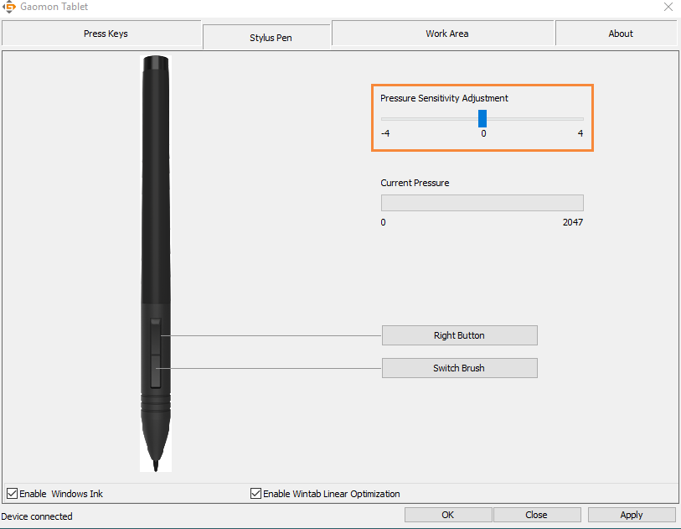

Pen Pressure Testing

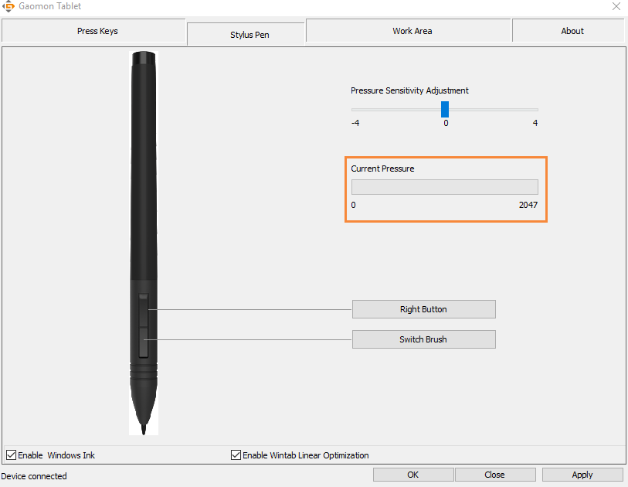
You can apply pressure gradually to the stylus as well as watch the pressure level on the screen.

Enable the Windows Ink feature
Microsoft Windows provides extensive support for pen input. Pen features are supported in such as Microsoft Office、Windows Journal、Adobe Photoshop CC 2014、SketchBook6 and so on.
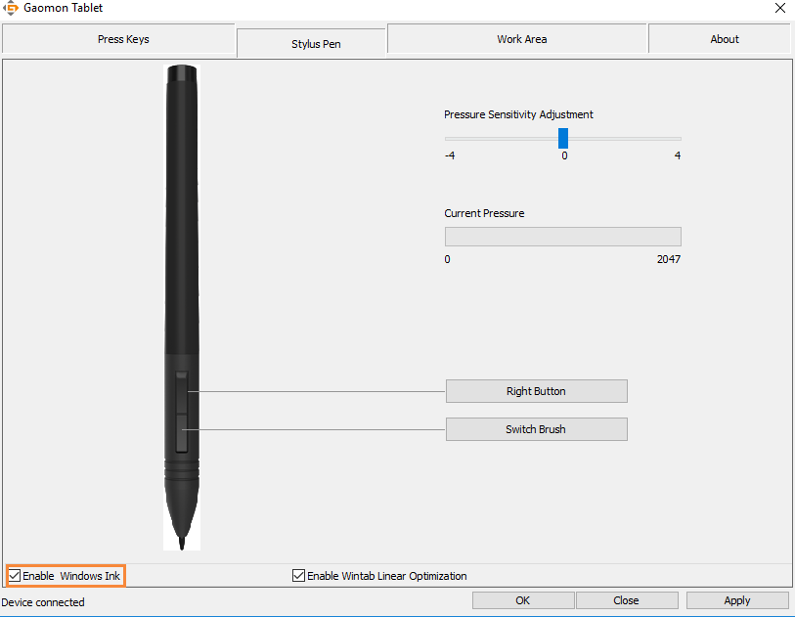

Data Export and Import
The driver supports exporting and importing your custom configuration data of the product, which is convenient for you to use different software and avoid the trouble of repeated settings.
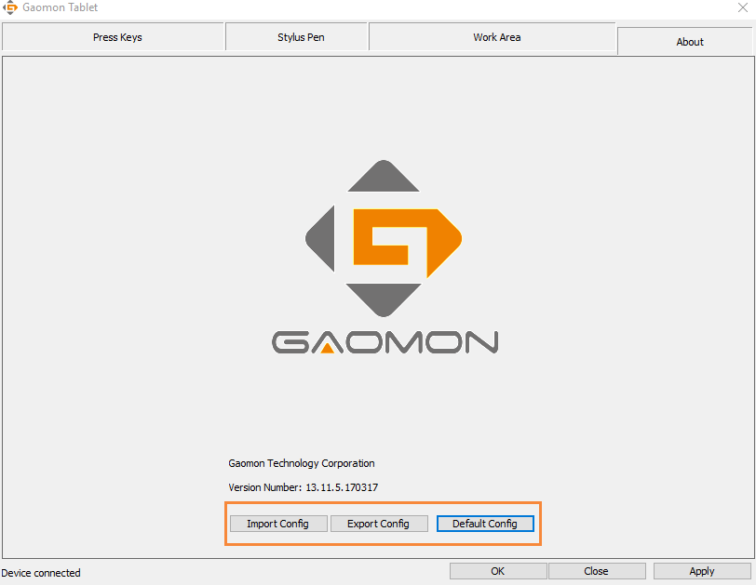

Troubleshooting

Please refer to the following tables if you encounter any problems.
Problems | Suggested action
The pen is no function | - Make sure you have installed the driver correctly.  - Make sure the driver is running.  - Make sure the pen is full of power.  - Try using mouse to double check, if mouse also no function, please restarting your computer or your application.  - Try to reconnect the cable.  - Try to reinstall the USB Tablet driver.
Pen nib is too short | * Replace the pen nib if it is too short.
The cursor move Incorrectly | - Eliminate interference from nearby electrical devices.  - Try restarting your computer for double check.
The side switch does not work | - Be sure that the pen nib is within 10mm of the tablet surface but not against the tablet surface when you press the side button.  - Be sure that the side button is set to the proper function you are expecting to occur for the  application.

Product Specification

Graphics Tablet
Model | M106K
Pen Technology | Electromagnetic Resonance
Working Area | 254 x 158.8mm（10X6.25”）
Dimension | 359.6 x 240 x 10.5mm
Color | Black
Net Weight | 780g
Touch Resolution | 5080LPI
Report Rate | 233PPS
Pen Sensing Height | 10mm
Interface | MINI USB
Express Keys | 12 Customized Express Keys
Function Keys | 16 Customized Function Keys
OS Support | Windows 7/8/8.1/10, MAC OS 10.10 or later
Stylus Pen
Model | ArtPaint AP20（Rechargeable）
Dimension | 149 x 12.7mm
Weight | 14g
Pressure | 2048Levels
Battery Life | Approx. 350
Automatic Sleep | 10min
Accuracy | ±0.3mm

