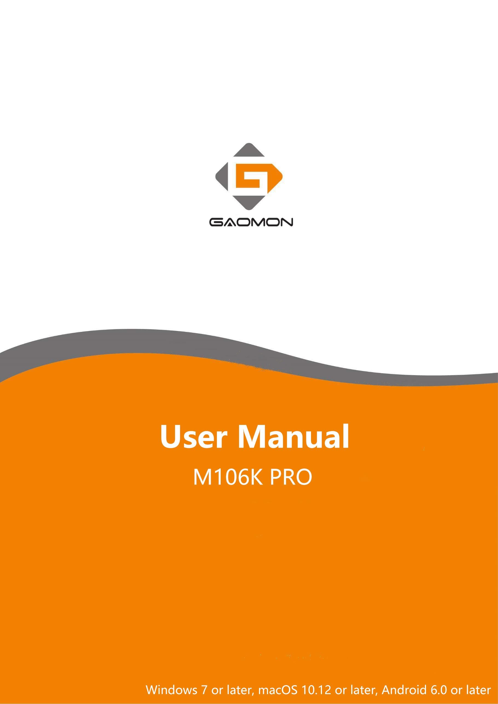
Precautions

1. Please read this manual carefully before using, and keep it well for future reference.

2. Before cleaning the tablet please unplug the power cord and wipe with a soft damp cloth, do not use any kind of detergents.
3. Don’t expose this product to water or other liquids. Take care to never spill liquids onto the tablet and pen. Exposing this product to water or other liquids may cause product malfunction or electrical shock.
4. Do not place the tablet on where is unstable or a height for children reaching easily in order to avoid danger. Prevent children from swallowing the pen nib or side switch. The pen nib, side switch, or other movable parts may accidentally be pulled out if children are biting on them.

CONTENTS
Precautions 0
- Product Overview 2
  - Tablet Introduction 2
  - Product and Accessories 2
  - Tablet Connection 3
  - Driver Installation 4
  - Connecting to Android Phone & Tablet 4
  - Digital Pen Overview 5
  - Pen Nib Replacement 5
- Function Setting 6
  - Device Connection Prompt 6
  - Working Area Setting 7
  - Shortcuts Keys Function Setting 10
  - Pen Buttons Function Setting 11
  - Pressure Sensitivity Setting 12
  - Pen Pressure Testing 13
  - Enable the Windows Ink feature 14
  - Mouse Mode 15
  - Data Export and Import 16
- Specifications 17
- Trouble Shooting 18
- Contact Us for After-sell Service 18

Product Overview

  - Tablet Introduction
Thanks for buying GAOMON M106K PRO Tablet. This is a new generation of professional battery- free drawing tablet, which can greatly improve your work efficiency of painting and creation, and full of fun. You can freely painting and writing, depicting different lines and colors, just as the pen writes on the paper, which brings you a real shock experience.
To give you a better understanding and using of your tablet, please read this user manual carefully. The user manual only shows the information under Windows, unless otherwise specified, this information applies to both Windows and Mac systems.

  - Product and Accessories

    - Graphics Tablet
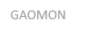
GAOMON

    - Packing List
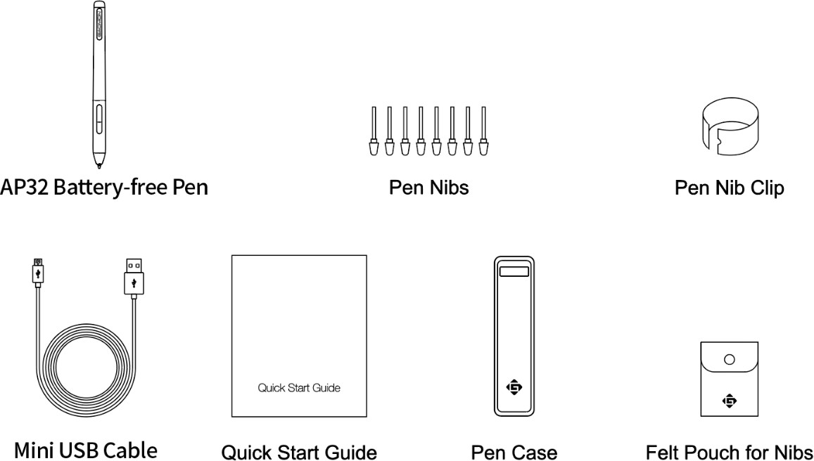

  - Tablet Connection
Connect the tablet to your computer with USB cable.

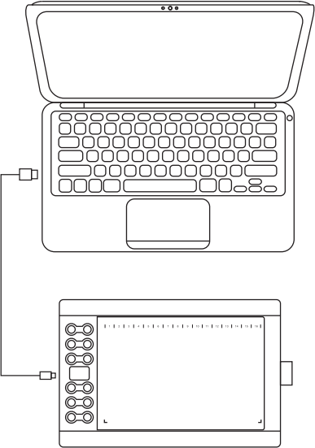
GAOMON

  - Driver Installation

    - OS Support

Windows 7 or later, macOS 10.12 or later, Android 6.0 or later

    - Install Driver
Please download the driver from our website: www.gaomon.net/download

After finishing installation, you can find the driver ico in the system tray area, which means the driver was installed successfully; when you connect the tablet to computer, the icon will change to color , which means the driver has already recognized the tablet and you can start using it now.
n
Notice：
- Before installing, you need to uninstall other driver of similar products, including GAOMON previous driver.
- Before installing, please close all graphics software and anti-virus software to avoid unnecessary mistakes.

  - Connecting to Android Phone & Tablet
- Please use Android phone/tablet in portrait mode.

- Please make sure your phone/tablet OS is as following: Android OS 6.0 or later

- For some models, you need to go phone or tablet "Settings" then enable "OTG" function.

- 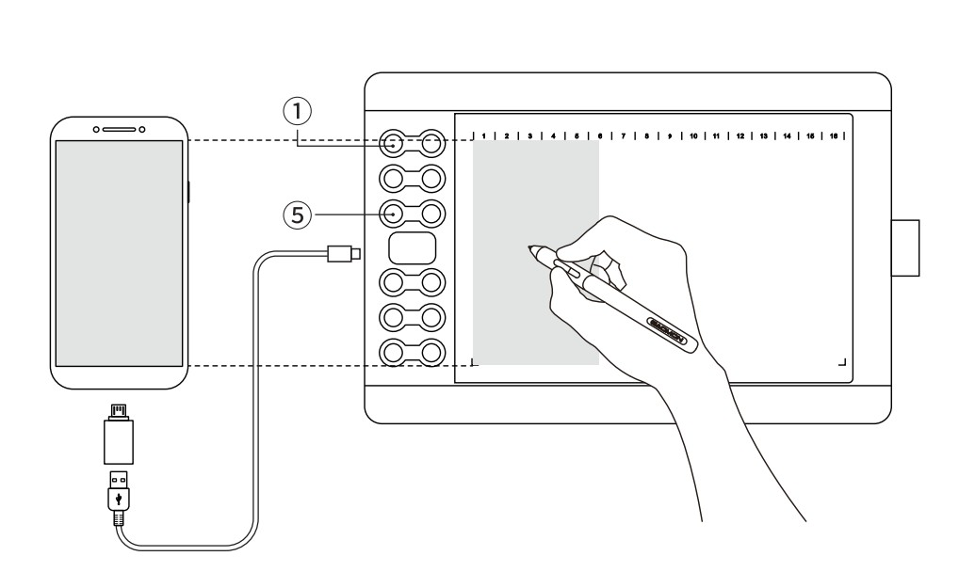Choose the right OTG Adapter from package, which depends on USB port type of your phone/t ablet, then connect pen tablet to your phone following the illustrations below:
GAOMON
4 / 18 www.gaomon.net

Notes:

- The pen tablet can work without installing any driver into your phone/tablet.

- Once connected, the tablet will automatically enter phone mode, in which the pen can only work in the left gray area(158.8x89.3mm).
- If it fails to recognize the tablet as the phone mode, please press the button ①，⑤ at the same time for 3 seconds to enter phone mode.
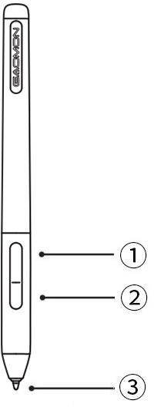
  - Digital Pen Overview

① : Upper button：Right mouse key function(default)
② : Lower button: Eraser function(default)
③ : Pen nib: Left mouse key function

  - Pen Nib Replacement
The nib will be wear off after using for a long time, then you need to replace a new nib.

- Use the pen nib clip to pull the old nib straight out of the pen. (①②）

- Insert a new pen nib into the stylus and push the nib until it stops. (③④）
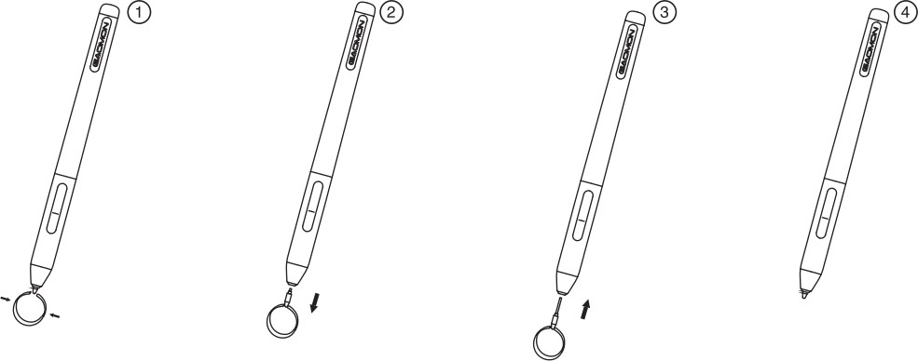

Function Setting

  - Device Connection Prompt
- Device disconnected: The computer does not recognize the tablet.

- Device connected: The computer has recognized the tablet.
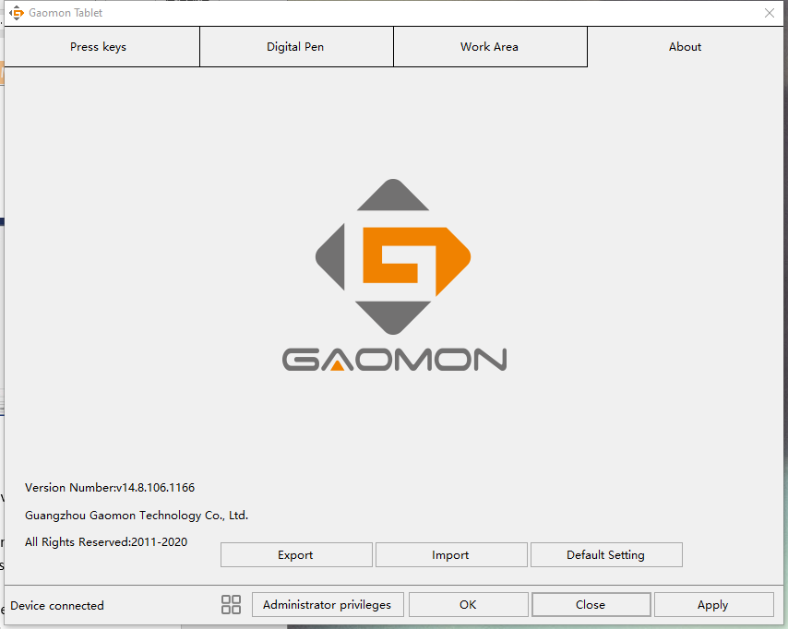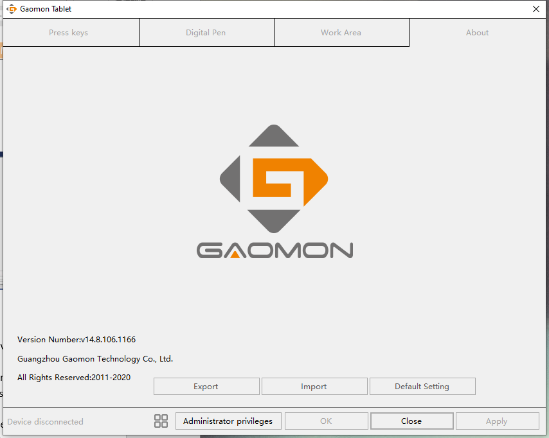

  - Working Area Setting

    - Using Multiple Monitors

Select the Working Area tab to define the relationship between pen movement on the tablet and cursor movement on the monitor screen.
By default the entire active area of tablet maps to the entire monitor. If more than one monitor is in use and you are in extended mode, you need to choose the related monitor on the driver interface which you are going to map to.
If your monitors are in mirror mode (All monitors display the same content), the tablet maps to the entire space on each monitor and the screen cursor is displayed on each monitor simultaneously.

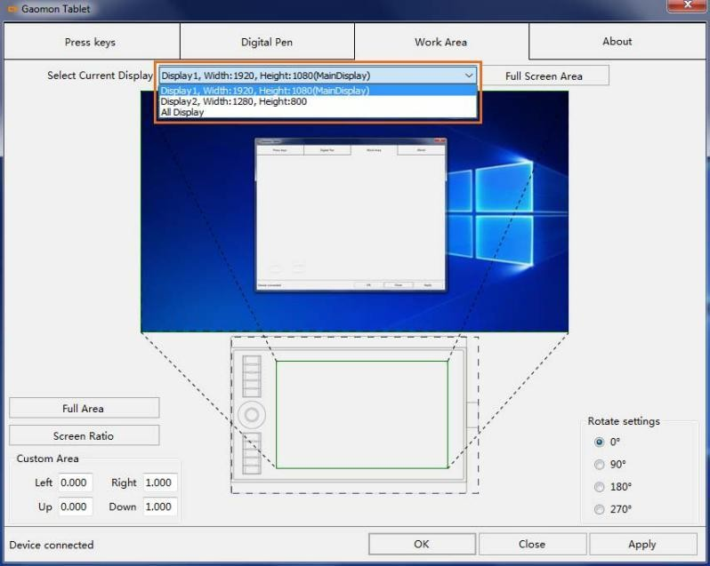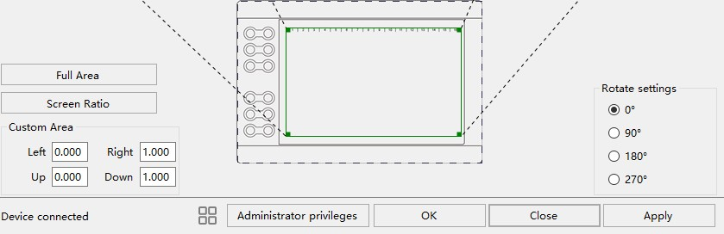

    - Working Area Setting

Define the tablet area that will be mapped to the screen area.

- Full Area: the entire active area of the tablet. This is the default setting.

- Custom Area: 1.> Enter coordinate values. Or 2.> Drag the corners of the foreground graphic to select the screen area.
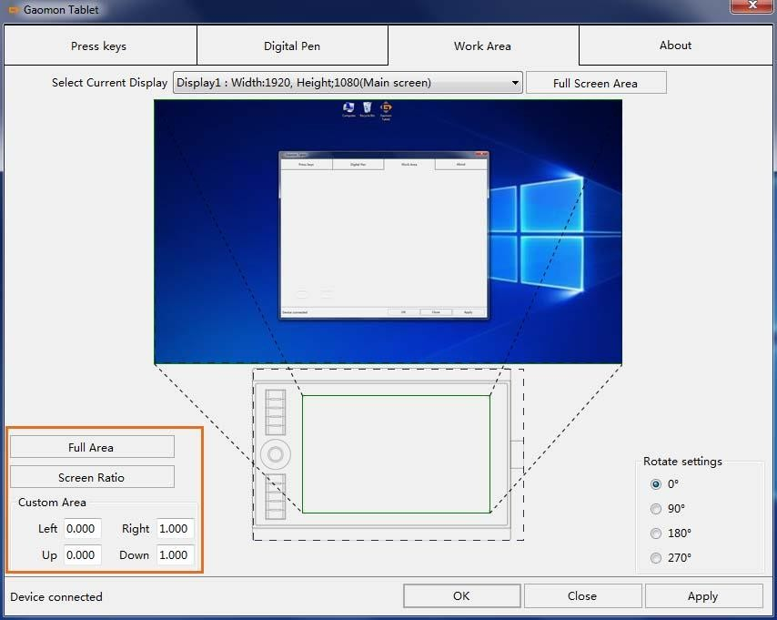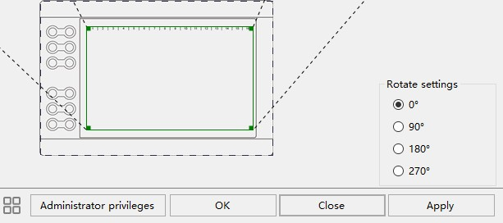

    - Rotate Working Area

By changing the direction of the tablet to adapt to the left and right hand operation. We provide four directions of choice.
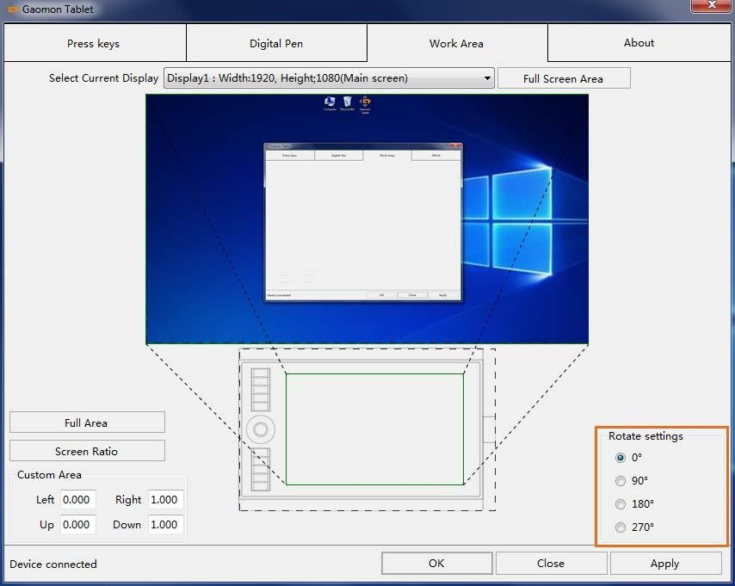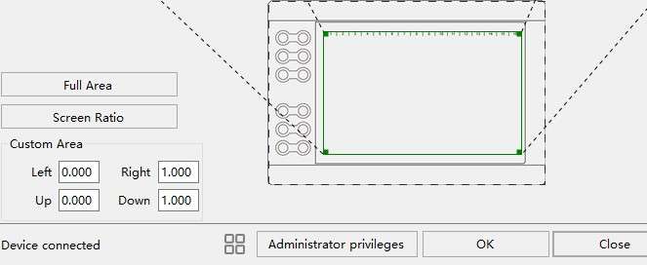

  - Shortcuts Keys Function Setting
Default Setting：Place the cursor on the shortcut key or click the press key to find the default values.

Customized Setting：Select the function to be achieved on the pop-up dialog box, then click APPLY or OK to take effect.
Enable/Disable Press Keys: Check/Uncheck”Enable Press Keys”
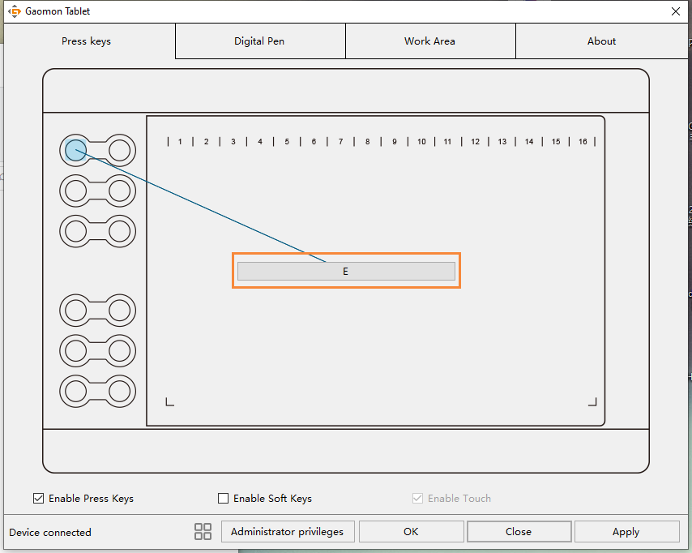
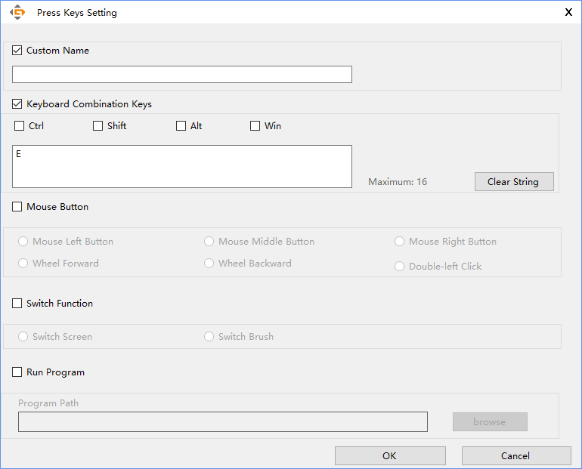
10 / 18 www.gaomon.net

  - Pen Buttons Function Setting
Select the function to be achieved on the pop-up dialog box, then click APPLY or OK to take effect.
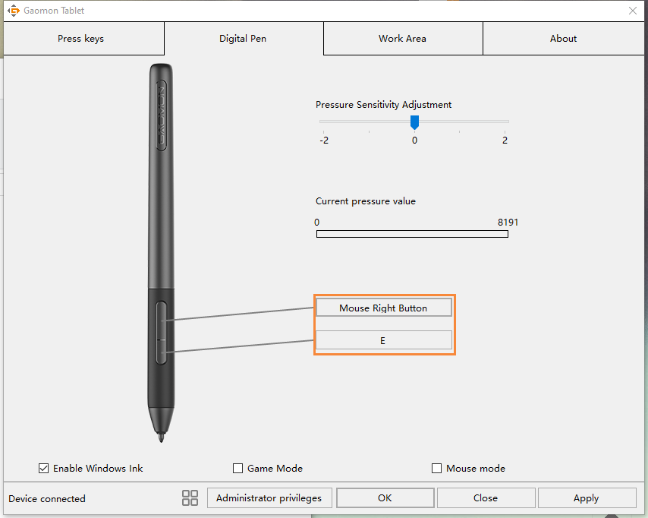
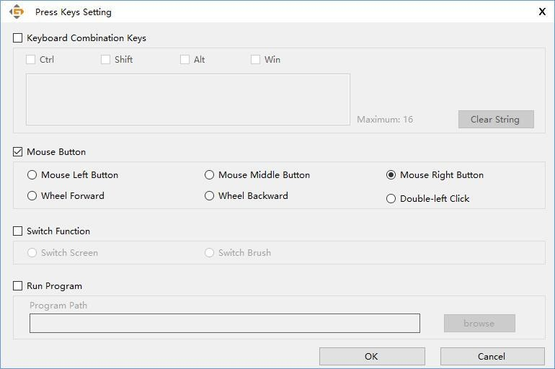

  - Pressure Sensitivity Setting
The pressure sensitivity will be changed by dragging the slider left or right, the smaller the value, the more the pressure sensitivity.
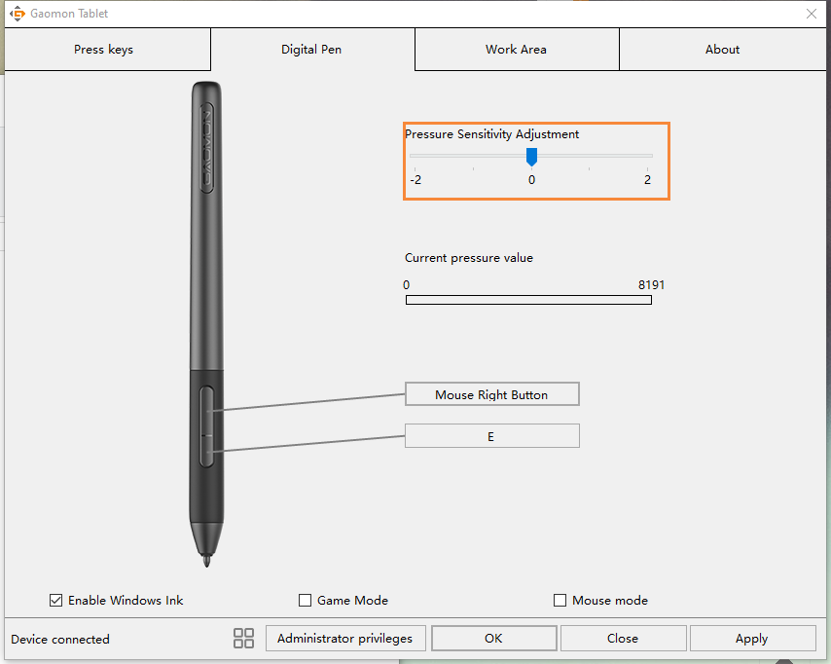

  - Pen Pressure Testing
You can gradually apply pressure to the stylus on the screen to test the pressure level.
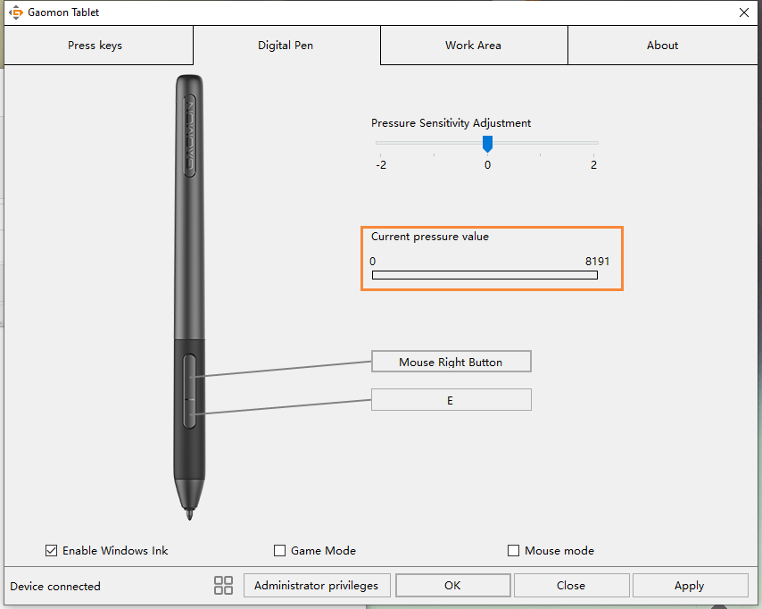

  - Enable the Windows Ink feature
Microsoft Windows provides extensive support for pen input. Pen features are supported in such as Microsoft Office、Windows Journal、Adobe Photoshop CC、SketchBook 6 and so on.
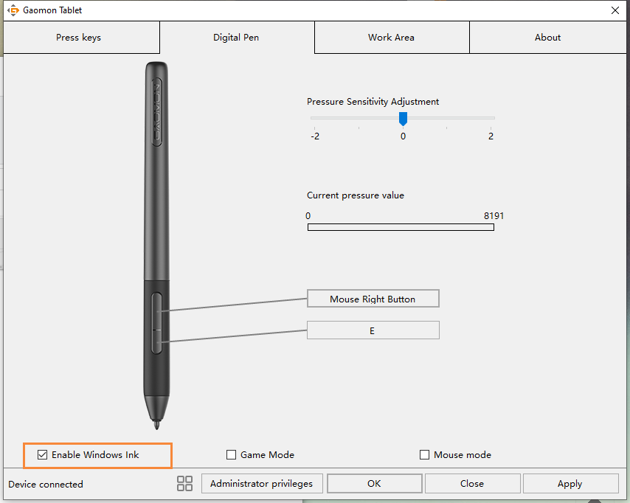

  - Mouse Mode
As shown below, check the checkbox in front of the mouse mode to open the mouse mode. Under mouse mode, when you move the pen, the cursor moves following the relative coordinate principle, similar to moving the cursor with the mouse. This means you can click icons or select options at the edge of the screen without moving the pen to the edge of the working area.
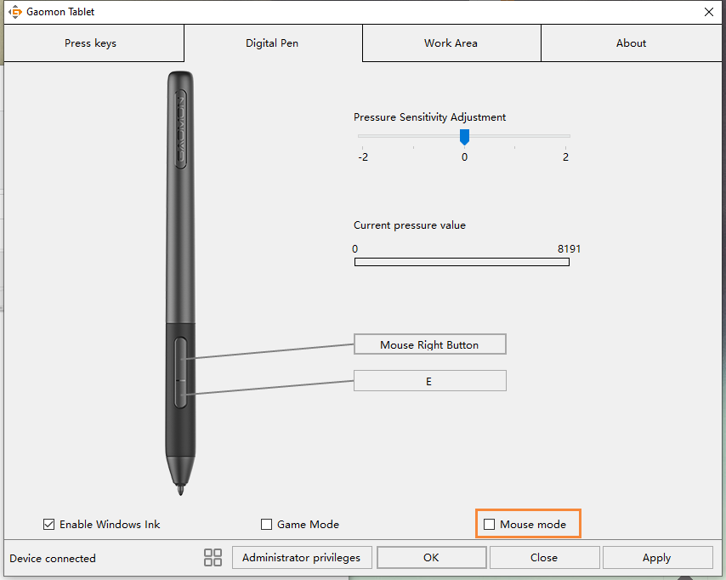

  - Data Export and Import
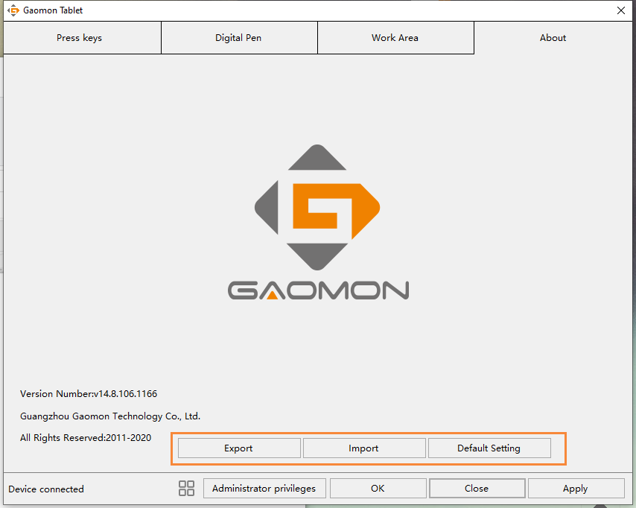
The driver supports exporting and importing your custom configuration data of the product, which is convenient for you to use different software and avoid the trouble of repeated settings.

Specifications

Model | M106K PRO
Touch Technology | Battery-free EMR
Working Area | 254 x 158.8mm
Dimension | 360 x 240 x 10.5 mm
Net Weight | 695g
Touch Resolution | 5080LPI
Report Rate | 266PPS
Accuracy | ±0.3mm
Pen Sensing Height | 10mm
Interface | Mini USB
Express Key | 12 Programmable Press Keys+16 Programmable Soft Keys
OS Support | Windows 7 or later, mac OS 10.12 or later， Android 6.0 or later
Model | AP32
Dimension | 160 x Φ12mm
Weight | 12g
Sensitivity Pressure | 8192 Levels

Trouble Shooting

For more FAQ, please feel free check：
https://blog.gaomon.net/faq-list/ or https://www.gaomon.net/question/

- Contact Us for After-sale Service GAOMON TECHNOLOGY CORPORATION www.facebook.com/Gaomonpentablet twitter.com/Gaomonpentablet
service@gaomon.net https://www.gaomon.net

