Graphic Tablet
User Manual
1
For Win

Content
- General Information 4
  - Overview 4
  - Pen Tablet Function.s 4
  - System Requirements 5
  - Installing the Driver Software on Window.. .s 7
  - Hardware Installation 7
  - Verifying Hardware and Driver Function. .s 7
  - Usage Tips 8
- Driver Interface Introduction 8

- Control Interface
- Pen Pressure Test

..................................................................................... 9

.................................................................................... 9

- Digital Pressure Sensitive Pen Settings 10
  - Key Functions 10
- Workspace and Shortcuts Settings 10
  - Workspace Settings 11
    - Express Shortcut Function Settings 10
- Digital Pen Pressure Sensitivity Test 13

Storing the Digital pen and changing the Pen Battery & Tip 13

Question & Answer 15

- The driver may already be updated to anewerversionpriortobe packaged. If your installation screen does not match the content of this manual, please refer to your software screen after installation.

Overview

General Information

Welcome to the world of tablet and digital pen! You are able to discover how easy to control your personal computer by using a wireless digital pen instead of a mouse:
The function of the digital pen is able to drawa very thin, thick, light or dark (called pressure sensitivity) line. You also can write, sign, annotate documents, and draw, sketch or paint as easily as you would on normal paper and simulate the functions like pencil, markpen, brush, or watercolor pen by using the commercial software packages such as Adobe Photoshop, Corel Painter and Paint Shop. If MSN Messenger is the newer one, you can create and send digital handwriting sand hand-drawnpictures, making communication much more funny and entertaining.

Note:If you cannot enable the handwriting mode in MSN Messenger, download the relevant handwriting component from Microsoft's website.

Pen Tablet Functions
After installing the device driver, your pen tablet has the following functions:

- Direct pointing – You can move the cursor to any are a of the screen by hovering the pen tip over the tablet’s surface.

- Three - buttons mouse commands – Your pen tablet provides all fun ctions of a three-buttons’ mouse by using its pen tip and two buttons.

- Pen scrolling – You can scroll documents and Web pages by pressing the middle button of the rechargeable pen over the tablet’s working area.

- Pressure sensitivity – This feature allows you to emulate various brushes and pencils and you can press down the pen tip harder, lighter, stronger or thicker, and subtle pen cil lines you will receive.

System Requirements
Windows 7/Windows 8/Windows 8.1/Windows 10

Installing the Driver Software on Windows
For Microsoft Windows 7/Windows 8/Windows 8.1/Windows 10 operating systems:
- Insert the Driver CD into the CD-ROM drive, and wait for the main installation screen to appear.
- The main installation screen should appear automatically, or you can manually start the installation by opening [My Computer] [ CD/DVD Rom] then click on the [Setup] program.
- When installing the driver, follow the installation instructions on screen and press the “Enter” key.

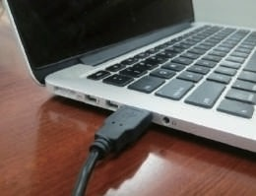
Hardware Installation

Connecting a tablet with USB interface into the PC after the driver installation is finished.
After connecting a pen tablet into the PC, you will seea small tablet icon（ ) appears in the system tray, which is normally at the lower right corner of the screen.

Verifying Hardware and Driver Functions
6.1 Follow the steps to verify if the wired tablet is installed properly:

Power ON/OFF

Button

Pen tip

Note: After the tablet's device driver has been properly installed, a small tablet icon ( ) will appear in the system tray, which is normally at the lower right corner of the screen.

Usage Tips

To store the pen, make sure the pen tip does not touch anything, and especially do not let the pen stand in a cup or pen holder with the tip down. Even though the possibility is low, constantly put stress on the pen tip might damage precise configuration of the pen. Place the pen in a pen holder, or turn the pen tip pointing upward or horizontally with the pen tip free of any pressure by other objects.

- Do not use more than two devices at the same time in case the screen cursor is jittering or not moving.

Control Interface

II. Driver Interface Introduction

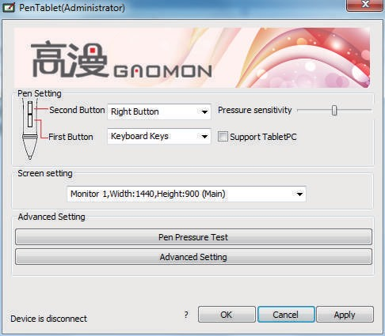
When you double click the driver tablet icon ( ) which normally appears in the system tray at the corner of the screen, you will see the control panel (pictured above). It will display driven-related information.
Controlling the panel by digital graphic tablet can set up functions for the button of the digital pressure-sensitive pen, regulate the pen’s pressure sensitivity and modify the workspace and shortcut keys.

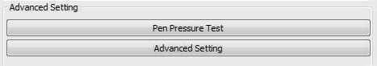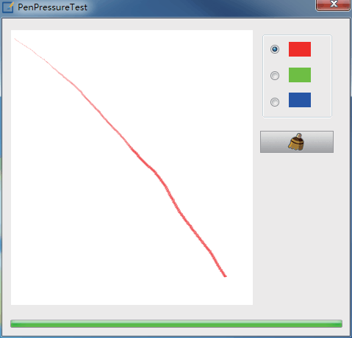Pen Pressure Test
Click Pen Pressure Test into Pressure Sensitivity Testing

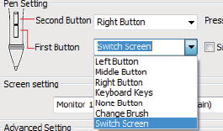
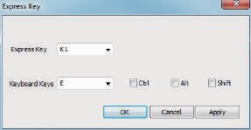
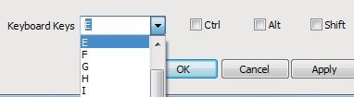
- Digital Pressure Sensitive Pen Settings
  - Key Functions

Below the key menu shows the defining keys of the digital pressure sensitive pen. Selecting its “left, middle,right, keyboard keys, no keys, change brush, switch screen” on the corresponding right drop-down menu of the pen function settings window’s “the first button, the second button” can achieve its functions.
When finished the first key and the second key selecting the keyboard keys, all the other keys can be freely defined.
When this done, you can achieve all the shortcuts keys functions of the graphic software.
Digital pressure sensitive pen default setting functions: 1.The pen nib is equivalent to the mouse left button function.
- When the first key is E, you can switch it to eraser in the graphic software(such as photoshop etc).
- The second key is equivalent to the mouse right function.

- Workspace and Advanced Setting

Click the ” Advanced Setting” button in tablet settings(see the selected area above), you can access the working area and shortcut key settings.

Advanced Settings

Area A:Softkey

Area D:Softkey settings area

The work area:Area A+Area C

Area B: Express key

Full Area

The work area:Area C

Disable softkey
Area C:the work area

Area A: SoftKey key settings area Area B: Express settings area Area C: The work area
Area D: Softkey has three settings: “Softkey Disable, Softkeys Enable,Full Area”.

Sofkeys Disable: select this key, the key function will be disabled in the work area. The graphic tablet’s work area is limited in the C area.

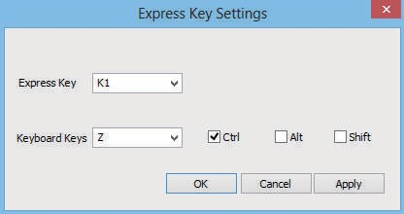
    - Express key function setting

Click the express keys of the area can enter into the express keys’ function setting screen(pictured above), the corresponding express key is from K1-K3 and K6-K8 of 6 express keys.

Selecting any express key, and then selecting the keyboard keys can setup functions for the selected express key. Attention: Select this key of " Disable Express Key" , the key founction will be disabled

Digital Pen Pressure Sensitivity Test
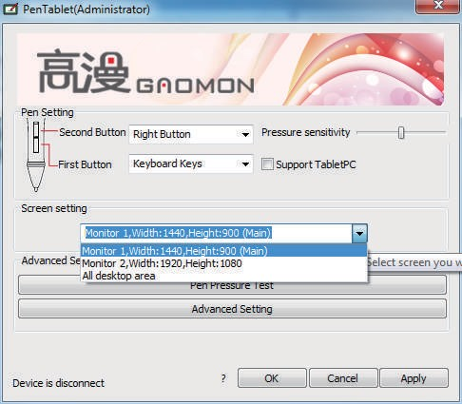

Pressure sensitivity: move the slider from left to right, it can be used to adjust the sensitivity of the tip and the severity of the stroke when drawing, which affects the change of the handwriting(red box area).

When your computer is connected with two screens and use the extended mode, you can choose the corresponding work area of the graphic tablet in the setup screen area(green box area).

Storing the Digital pen and changing the Pen Battery & Tip

Storing the Digital pen properly
To store the Digital pen, make sure that the tip does not touch anything, especially, do not let the pen stand in a cup or penholder with the tip down. Pressure applied to the
pen tip might damage the precise configuration of the pen, it is recommended to place the pen in a pen holder or store it with the pen tip pointing upward, or place it horizontally
with the pen tip free of any other objects.
Note: It’s recommended to turn the power off by pressing the power button at top of the pen to save battery. See below about how to change batteries.
Power ON/OFF

Unscrew Unscrew

Fig. (A) Unscrew the pen,

Button2 Button1

Pen tip
Cathode upward Anode downward

Fig. (B) Put an AAA battery into the pen-holder, + pole towards to pen tip end.
Hold down the power on/off button, then the pen works.
replacing the wireless stylus pen tip
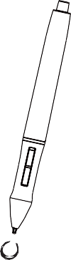
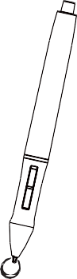
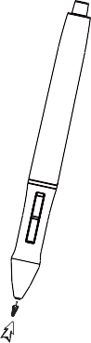
A: Pull out the pen tip from Digital pen by using a Pen Clip that contained inside the pen holder. Normal Pen Clip

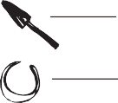
Pen Tip Pen Clip

B: Push the pen tip into the digital pen and make sure fit it up to the end properly.
Gently unscrew the pen holder in a counterclockwise direction.
you will see one pen tip replacement tool & 4 spare pen tips inside.
The pen tip replacement tool and 4 pen tips

- Question & Answer
Question 1: How can I get the update software?
Answer: You can download the new driver from our website.

- Uninstall your old driver: Click [Start] ► [All Programs] ► [TABLET] ► [Uninstall].
- Download the latest version of driver in the download section and save it into your hard disk.
- Unzip the file in a folder on your hard disk (with Windows built-in unzip utility or a program like Winzip for instance).
- Double-click the Setup.exe in the folder where you unzipped the file.

Question 2: The tablet cannot work. How can I do? Answer: Please follow steps as showing below:

- Please pull off the tablet's USB plug from the computer.
- Remove the Tablet driver from the system.
- Re-connect theTablet's USB to the computer.
(3.1) Test your wireless digital pen on tablet working area, if it can work as a mouse, which means the hardware is OK. If it doesn't work, please change the battery with a new one.
(3.2) After changing a new battery for the pen, if it still not working, it means that the hardware is faulty.
- You can download the latest version of driver directly from our website: www.gaomon.net.
- After installing the new version of driver, the system will require you to restart your computer.
- After restarting your computer, on bottom right of the screen, you can find the tablet icon ( ) within there.
(6.1) If you can't find the tablet icon ( ) on the bottom right of the screen, it means the driver fail in startup, which might be due to incompatibility.
(6.2) Check from [My Computer] ► [Properties] ► [Hardware] ► [Device Manager], if there is an exclamation mark occurs, it means the installed driver of tablet is incompatible with the windows system. If you have this problem, please contact us for more service.
- By clicking the tablet icon ( ) on the bottom right of the screen, you can test the pressure sensitivity to see whether the pen pressure function works or not. If you do not have the pen pressure, it means the pen might be faulty. (Please see Chapters 2, Section 6. — Pen Tablet Configuration for more information).

Support Tablet PC
Also called Electronic Ink Function, which is normally used for supporting pressure sensitivity under Office 2007, Journal or later version. For Sketchbook 6.0, Photoshop CC2014(or later) on Windows8 or later system, checking "Support TabletPC" is needed to support pressure sensitivity.

As for other drawing software, please read the software instruction carefully to see whether it supports windows TabletPC or not, and try to disable Support TabletPC if it is needed.
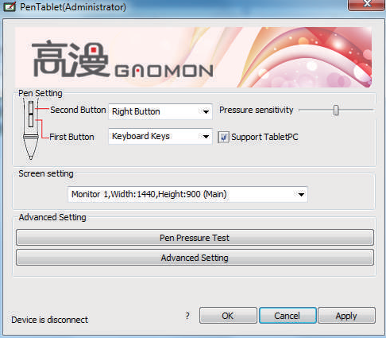

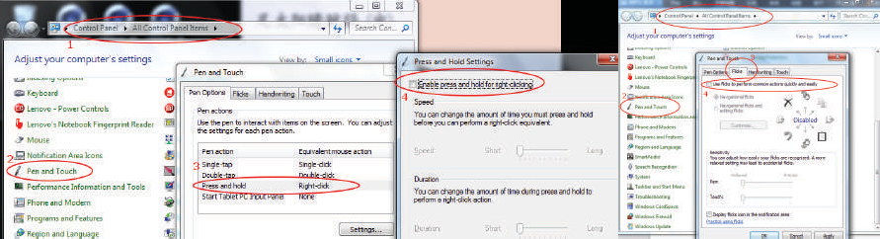
As the “Support TabletPC” checked, please turn off flicks to get a better using experience.

Guangzhou Gaomon Electronic Technology Co.,LTD

Room 2708, Buynow Building, No.592, Tianhe Road, Tianhe District, Guangzhou, China www.facebook.com/Gaomonpentablet
twitter.com/Gaomonpentablet service@gaomon.net
http://www.gaomon.net

