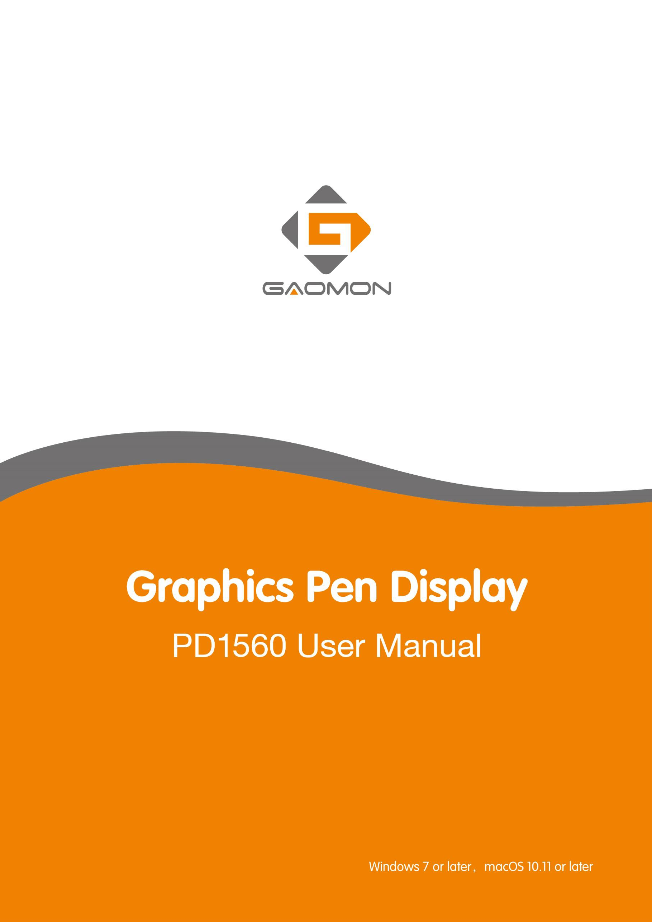

Precautions
- Please read this manual carefully before using, and keep it well for future reference.
- Before cleaning the display please unplug the USB cable and wipe with a soft damp cloth, do not use any kind of detergents.
- Please don’t place the display near water sources such as bathtub, washbasin, sinks, washing machine, damp basement, swimming pool, etc.
- Do not place the display on where is unstable or a height for children reaching easily in order to avoid danger.
- Do not place the display and digital pen close to the magnetic field.
- The grooves and holes on the back case is designed for ventilation to prevent the monitor from overheating. Please don’t place the display on beds, sofas, carpets or in embedded device.
- Only power supplies shown on the nameplate can be used for the display. If you have questions about the power supply which you are using, please consult the distributor of your display.
- To protect your display, please switch off the power when it is not in use. During blackouts or not using for long time, please unplug the display from the socket.
- Don’t overload the socket or lengthen the power wire, which may lead to electric shocks.
- Make sure no foreign bodies get inside the monitor through grooves and prevent liquid from splashing on the display as to prevent short-circuit or fire.
- If the display has a breakdown, do not open the main case and try to repair it by yourself. Please ask for a service for proper repair and maintenance.
- When the following situations occur, please unplug the power adapter and you may need a service for full repair and maintenance:
- The power wire or plug is damaged or worn out;
- There is liquid splashed inside of the display;
- The display has fallen or the LCD is broken;
- When obvious abnormalities occur to the display。
- While getting the components replaced, you are supposed to guarantee that the repairman is using the substitute components specified by the manufacturer. Unauthorized component replacement might cause fire, electric shocks or other dangers.
- Digital pen has a lithium battery, which should be charged in time under low battery mode, and at the same time should be charged every 3 months; otherwise it will cause lithium battery damage.
- The nib of the digital pen can’t be pressed when it is placing, otherwise the pen can’t enter the power-saving state, which is easy to cause lithium battery over-discharge damage.

Contents
- Product Overview 3
  - Display Introduction 3
  - Product and Accessories 3
  - Display Connection 6
  - Driver Installation 7
  - Pen Nib Replacement 7
  - Charging the Pen 7
- OSD Function 8
- Function Setting 8
  - Device Connection Prompt 8
  - Working Area Setting 9
  - Press Keys Function Setting 10
  - Pen Button Setting 11
  - Pressure Sensitivity Setting 12
  - Pen Pressure Testing 12
  - Calibration 13
  - Enable the Windows Ink feature 14
  - Data Export and Import 14
- Specifications 15
- Trouble Shooting 16
  - Possible Breakdowns Related to DISPLAY 错误！未定义书签。
  - Possible Breakdowns Related to FUNCTIONS 错误！未定义书签。

Product Overview
  - Product Introduction
Thanks for choosing GAOMON® PD1560 graphics display. This is a new generation of portable desktop-level professional drawing display, which can greatly improve your work efficiency of painting and creation, and full of fun. You can freely painting and writing, depicting different lines and colors, just as the pen writes on the paper, which brings you a real shock experience.
To give you a better understanding and using of your display, please read this user manual carefully. The user manual only shows the information under Windows, unless otherwise specified, this information applies to both Windows and Macintosh systems.

Product and Accessories

    - Display Overview

Express keys Working Area

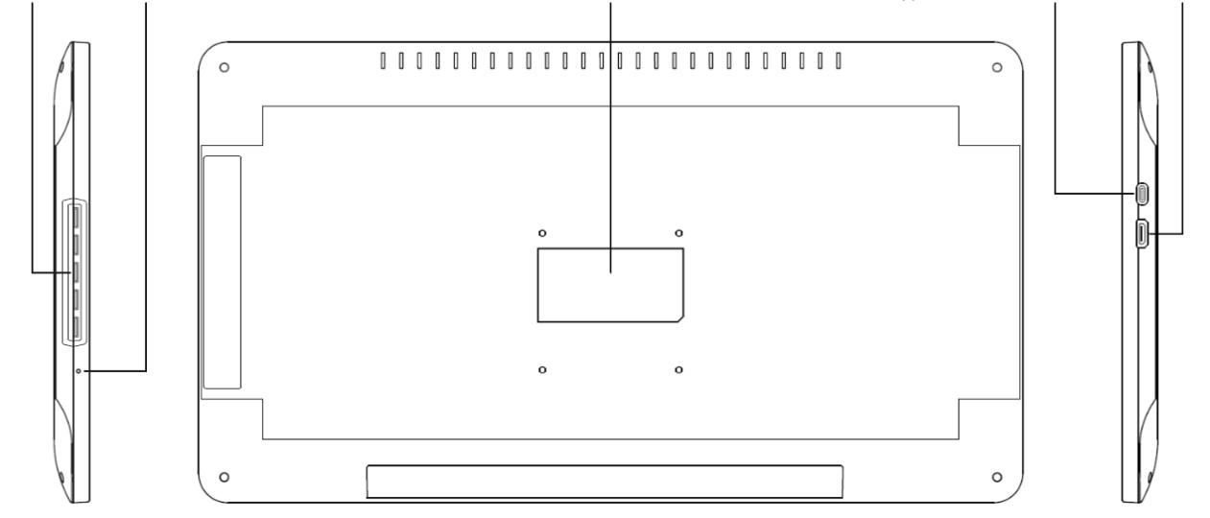OSD Buttons LED Indicator Nameplate USB Type-C Video Interface
3 / 17 www.gaomon.net

    - Stylus Pen

The stylus pen is a rechargeable pen with 8192 levels pressure sensitivity and can be used for 350hrs with full battery.
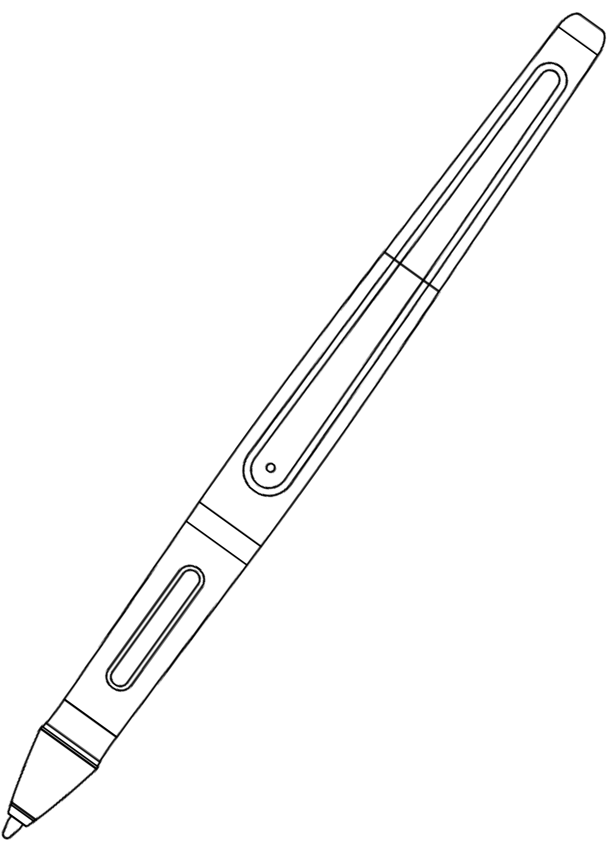Charging Port

LED Indicator

Upper Button（Mouse Right Key ）

Lower Button（Switch Brush）

Pen Nib（Mouse Left Key）
    - 3-in-2 Connection Cable

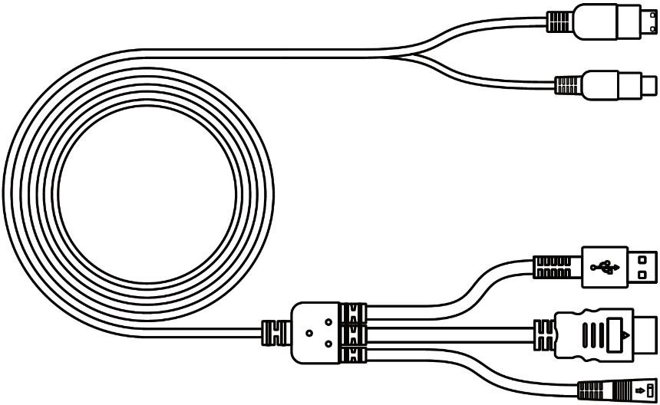
①

②

③

④

⑤

①Video ②USB Type-C ③USB A ④HDMI ⑤Power
4 / 17 www.gaomon.net

    - Power Adapter

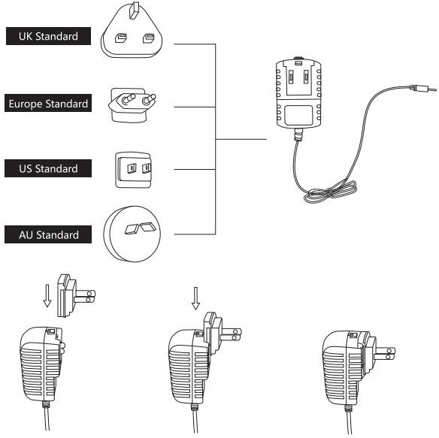
Please choose the right plug according to your country or region, and assemble it to the power adapter.（It may not come with all the plugs）
    - Adjustable Stand

We designed this ergonomic adjustable stand specially for your display, you can adjust the angle of the display according to your usage habit, and make you feel more comfortable when painting and creating.
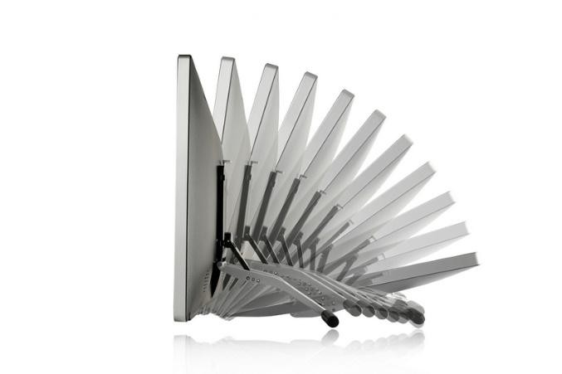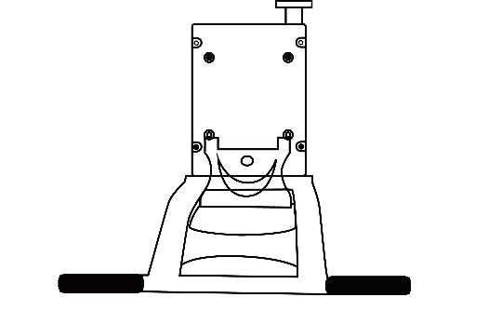
By dragging this switch to adjust
the stand angle from 20°-80°
5 / 17 www.gaomon.net

    - Other Accessories
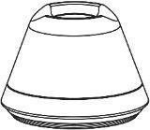
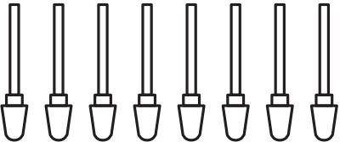
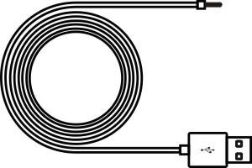
Pen Holder Replacement Nibs Charging Cable

Protective bag Quick Start Guide

Display Connection

- Connect your PC and the display with integrated cable.
- Plug the power adapter into the cable power connector and turn it 90 ° to ensure that the plug does not come off and connect the power adapter to the power source.
- Turn on computer and switch on the display, the LED indicator will show the current status：Green means working normal, Red means no signal.
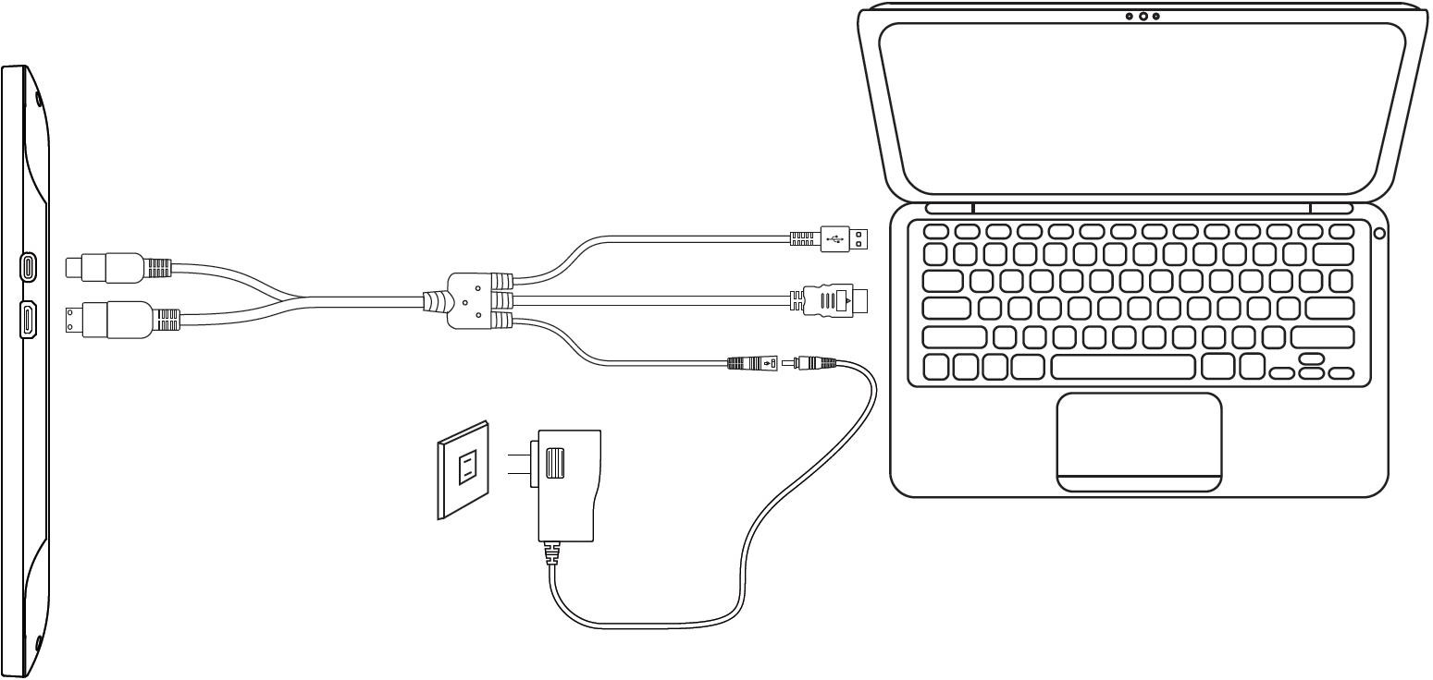

6 / 17 www.gaomon.net

Driver Installation
    - OS Support
Windows 7 or later，macOS 10.11 or later 1.4.2 Install via Download
Please download the driver from our website: www.gaomon.net
After finishing installation, you can find the driver ico in the system tray area, which means the driver was installed successfully; When you connect the display to computer, the icon will change to color , which means the driver has already recognized the display and you can start using it now.
n

Notice：
- Before installing, you need to uninstall other driver of similar products.
- Before installing, please close all graphics software and anti-virus program to avoid unnecessary mistake;

Pen Nib Replacement
- The nib will be worn out after using for long time, then you need to replace a new nib.
- Anticlockwise rotate the holder to open the cover, then take a new nib out.
- Insert the pen nib into the bottom hole and tilt the pen to pull out the nib.
- Insert the new nib into the pen and push it straight until it stops.
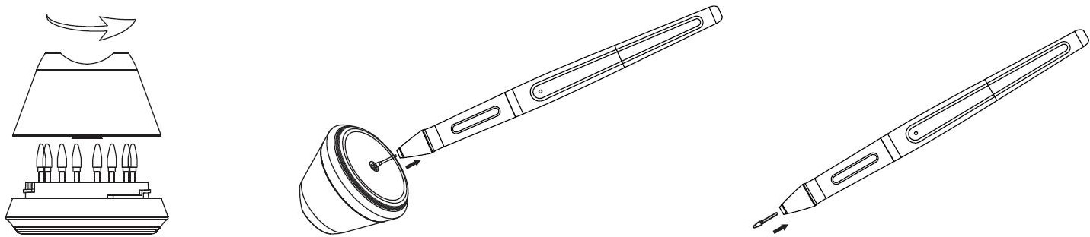

Charging the Pen
- When the indicator on the pen shows orange, it means the voltage of the pen is low, then you need to charge the pen.
- Charge the pen with the attached charging cable. Insert one end of the charging cable into the rear of the stylus charging port, the other end can be connected to a computer, power supply or power bank.
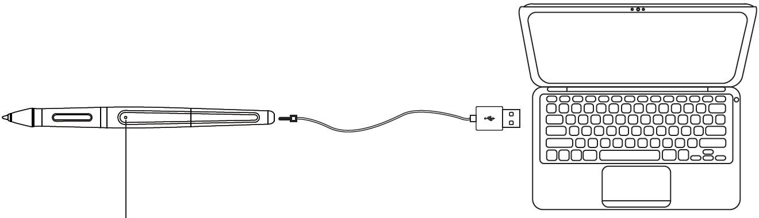

Bright White: Charging
Slight white light: Full Charge Orange: Low Voltage
7 / 17 www.gaomon.net

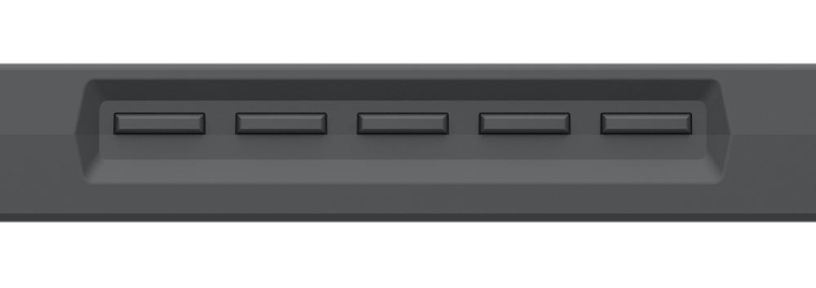
2. OSD Setting
AUTO
MENU
POWER

AUTO Before entering menu, it’s function is auto adjustment. After entering
menu, it’s function is back to previous menu.
----- After entering menu, it’s function is to down/left/decrease.
----- After entering menu, it’s function is to up/right/increase.
MENU Press to call up the menu, after entering menu, it’s function is confirm.
POWER Power on/off the display.
Remark： Through the OSD menu, you can adjust the screen brightness, contrast, color and other parameters.

Function Setting

Device Connection Prompt
1.Device disconnected: The display hasn’t connected to your computer. 2.Device connected: The display has already connected to your computer.
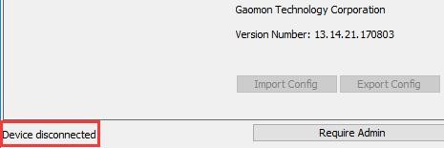
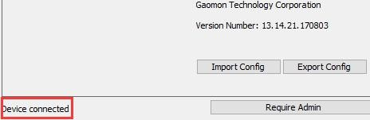
8 / 17 www.gaomon.net

Working Area Setting
    - Using Multiple Monitors
When the GAOMON Display and other monitors are used in the same system, the movement of the screen cursor on the standard display depends on the system configuration.
If the secondary display is a mirrored mode connection, this display and another monitor will display exactly the same image and screen cursor movement.
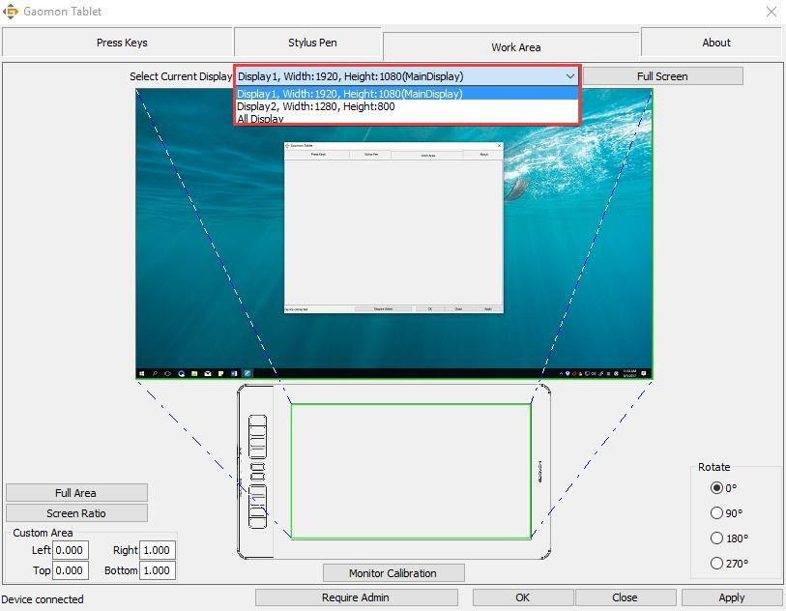
If you are in the extended display mode, you need to set the display on the driver that which portion of the display screen your display will map to.
    - Working Area Setting
Define the display area that will be mapped to the screen area.
- Full Area: the entire active area of the Display. This is the default setting.
- Same Ratio with LCD.
- 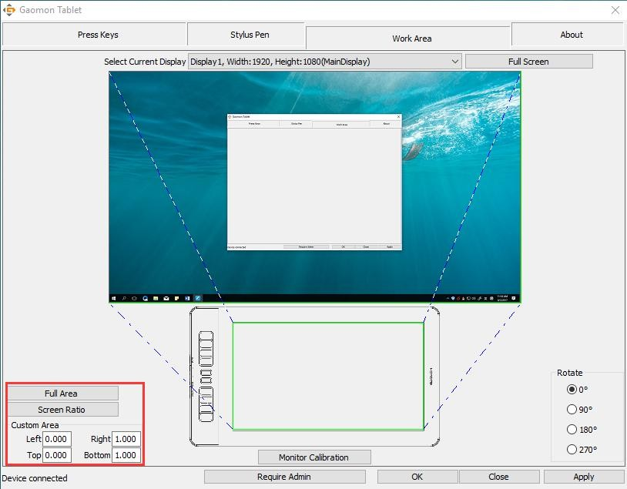Customized Area: 1.> Enter coordinate values. or2>. Drag the corners of the foreground graphic to select the screen area.
9 / 17 www.gaomon.net

    - Rotate Working Area
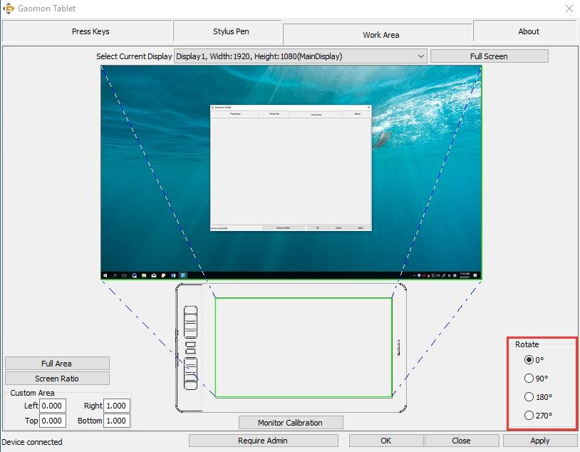
By changing the direction of the display to adapt to the left and right hand operation. We provide four directions of choice.

Press Keys Function Setting
Default Setting: Place the cursor on the button or click the button icon to see the default values for the press keys
Customized Express Keys: Select the function to be achievedon the pop-up dialog box, then click APPLY or OK to take effect.
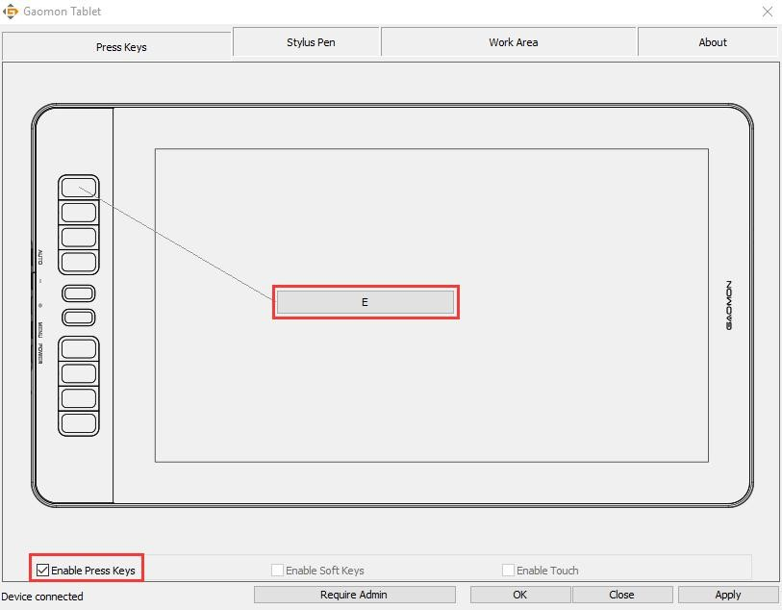
Enable/Disable Press Key: Check/Uncheck”Enable Press key”

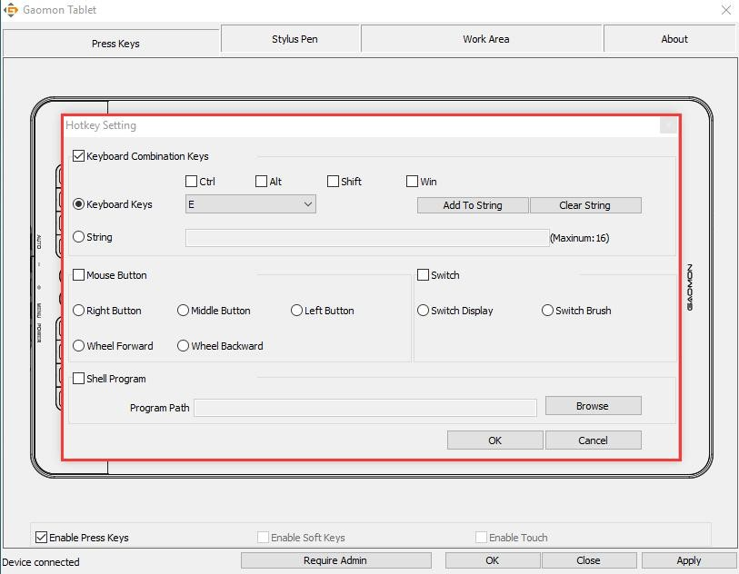

Pen Button Setting
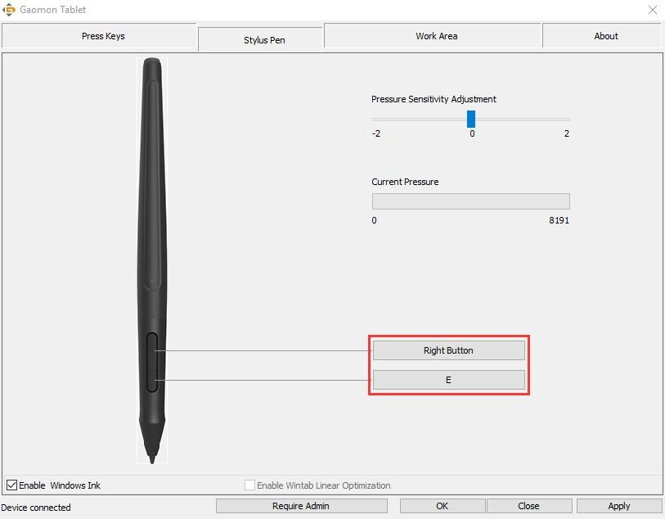
Select the function to be achieved on the pop-up dialog box, then click APPLY or OK to take effect.

Pressure Sensitivity Setting
The pressure sensitivity will be changed by dragging the slider up and down, the
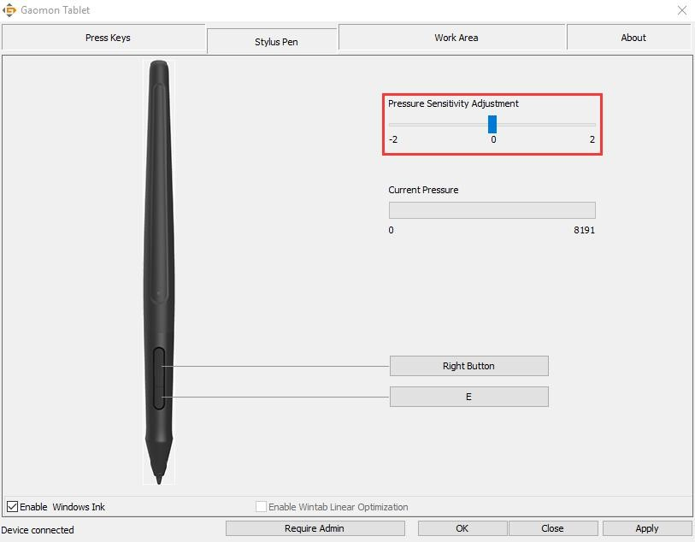
smaller the value, the more sensitive the pressure.

Pen Pressure Testing

Click “start pressure test”, you can gradually apply pressure to the stylus on the screen to test the pressure level. Click “Clear” button to clear all the ink.
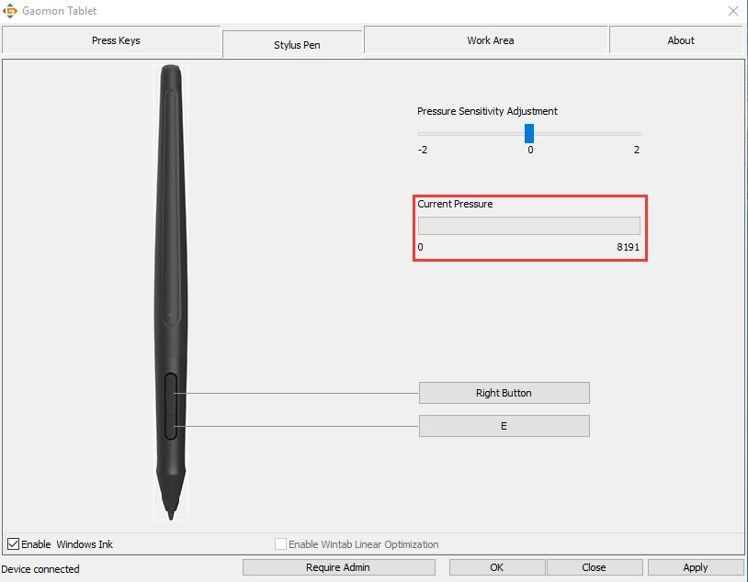

Calibration
Screen Calibration: Click the red point of the cross center appearing on the screen to complete the calibration.
Restore Factory Settings: Click "Restore Default" to restore to the factory settings. Cancel Calibration: Click"Cancel calibration” or press ESC on the keyboard to cancel the calibration.
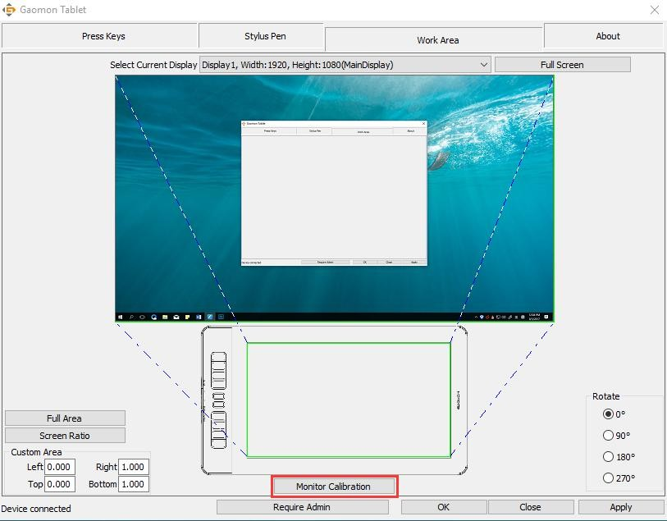

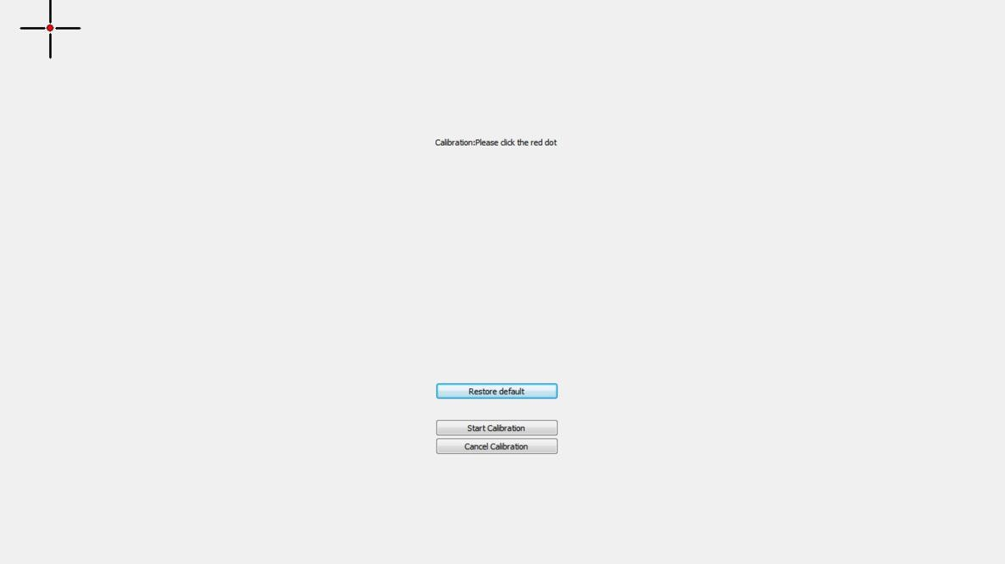

Enable the Windows Ink feature
Microsoft Windows provides extensive support for pen input. Pen features are supported in such as Microsoft Office、Windows Journal、Adobe Photoshop CC、SketchBook 6 and so on.
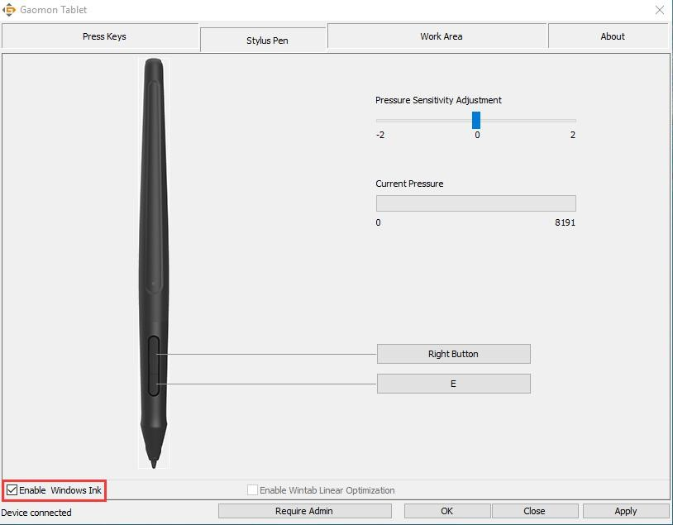

Data Export and Import

The driver supports exporting and importing your customized configuration data of the product, which is convenient for you to use different software and avoid the trouble of repeated settings.
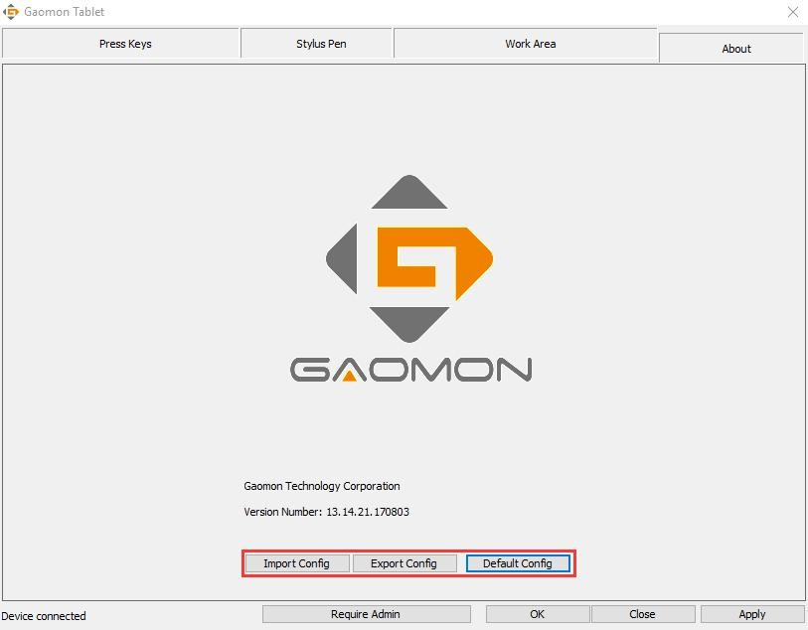

Specifications

Model |  | PD1560
Screen | Panel Size | 15.6inch
 | Resolution | 1920 x 1080(16:9)
 | LCD Type | TFT LCD IPS
 | Active Area | 344.16 x 193.59mm
 | Contrast Ratio | 1000:1
 | Brightness | 250cd/m2
 | Response Time | 25ms
 | View Angle | 89°/89°(H)/89°/89°(V)  (Typ.)(CR＞10)
 | Gamut | 72%(NTSC)
 | Display Color | 262K
Touch | Touch Type | Electromagnetic Resonance
 | Resolution | 5080LPI
 | Pressure Level | 8192
 | Accuracy | ±0.5mm（Center）  ±3mm（Corner）
 | Sensing Height | 10mm
 | Report Rate | 233PPS
Pen | Model | Artpaint AP40
 | Type | Rechargeable Pen
 | Net Weight | 16.5g
 | Dimension | Φ13.5x 177.5mm
 | Buttons | Two Customized Press Key
 | Battery Capacity | 80mAh
 | Charge Time | 1.3hrs
 | Life Time | 350hrs
 | Auto Sleep | 15mins
General | Working Power Consumption | 12W
 | Input Voltage | 100-240VAC, 50/60Hz
 | Output Voltage | DC12V 1A
 | Video Interface | HDMI
 | Press Key | 10 Customized Press Key
 | Dimension | 452.4 x 252 x 19.5mm
 | Net Weight | 1.58Kg
 | Adjustable Stand | 20°-80°
 | OS Support | Windows 7 or later,  macOS 10.11 or later

Trouble Shooting、

Possible Breakdowns Related to DISPLAY

Abnormal Phenomena | Possible Solutions
Power indicator does not flash | *Make sure power is on *Check the socket and power cable
No signal--saving power--all black | - Make sure the 3-in-2 cables are well connected.  - If you use a desktop, make sure the HDMI port is plugged into the graphic card on the tower, but not into the motherboard.  - If you use a Windows OS computer, make sure to press ''Windows+p'' on keyboard, then choose Duplicate or Extend. Don’t choose Computer Only or Projector Only.  - If there is no HDMI port on your computer, you need an extra HDMI adapter. We DON’T recommend a USB to HDMI adapter. Also we don’t recommend a USB hub. We recommend DVI/ VGA/ Display Port/ Type-C/ Thunderbolt, etc to HDMI adapters.
Nothing displays at all，with no indicator light. | 1.Make sure the power cord is well connected. 2.Try different power socket.
Displays wallpaper & task bar of computer monitor only. | - It is because you are under extended mode right now. It is normal situation.  - If you are not familiar with extended mode, we recommend you to use in Duplicate/Mirror mode. Windows OS: Press keyboard combination---windows+p---then choose Duplicate  Mac OS: System Preference---Displays--- Arrangement--- Check "Mirror Displays"  - If you decide to use in Extended mode. Make sure to choose pen display as Work Area in GAOMON Driver. It is usually ''Display 2''.
Images are blurred | Please set the display resolution with 1920 x 1080.
Lack of colors | Check the pins of the signal wire are not bent or fractured.
There is chromatic aberration | As the regional color temperature is different, so minor chromatic aberration is a normal phenomenon.

It is likely that there is electric equipment nearby that brings about electronic interference.

Possible Breakdowns Related to FUNCTIONS

Images jitter or ripple images appear

Abnormal Phenomena | Possible Solutions
Pen doesn’t work and no pressure in the graphics software | - When pen does not work in art programs only: Uninstall the driver and reinstall it. If you use Windows OS, make sure to ''run as administrator'' when installing the driver. (But not ''run as administrator'' on desktop after the driver has been well installed already)  - When pen does not work everywhere: Try re-inserting the USB cable. Try different USB ports on computer. Try different computer.
Cursor movement is abnormal | Try re-inserting the USB cable or restarting your computer.
The side button of the pen doesn’t work | When pressing the side button, please make sure that the nib didn’t touch the glass surface and the distance between the nib and surface is within 10 mm
There is a deviation between  the tip and the cursor | Try calibration

GAOMON driver indicates ''device connected'', but the pen doesn ’ t respond in Mac OS
10.14 or above versions.
Find answer here:
https://www.gaomon.net/question/macos_mojave_catalina_solution.html

Note:
For more information, please contact us with our email: service@gaomon.net or find answer here https://blog.gaomon.net/faq-list/

